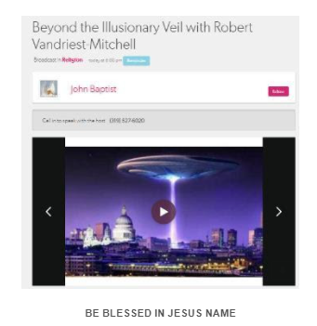

https://www.blogtalkradio.com/tribulation-now/2021/10/20/montauk-and-the-alien-threat-with-robert-vandriest-mitchell-41

PRAYER
- PRAISE YOU HOLY FATHER GOD
- CLEAR THE AIR!!!
- Send the Whirlwind of the Holy Spirit To blow the fire into a fire vortex, and punch through the spiritual realm into the Throne room of God
  - ANOINT US WITH HOLY SPIRIT
  - SUPERNATURAL PEACE
  - PRACTICE RIGHTEOUSNESS
  - CREATE IN US A CLEAN HEART
  - EMPTY OUR CUPS
- MAKE READY FOR HARVEST
  - SPIRIT OF BOLDNESS TO WITNESS
- OVERCOME SIN
- HEDGE OF PROTECTION,
  - ANGELS TAKE CHARGE
  - HELP US SEEK YOU MORE CLOSELY
  - PEACE DURING CALAMITIES
  - BRING FORTH THE LATTER RAIN

Jude 24-25
24 Now to Him who is able to keep you from stumbling,
And to present you faultless
Before the presence of His glory with exceeding joy,
25 To God our Savior,
Who alone is wise, Be glory and majesty,
Dominion and power,
Both now and forever.
Amen

Eph 5:27-28
27 that He might present her to Himself a glorious church, not having spot or wrinkle or any such thing, but that she should be holy and without blemish.
NKJV

ANNOUNCEMENTS:

- SIGN UP FOR EMAILS (Tribulation-Now.Org)

- SHOW TIME CHANGES

A Day is Not a Lifetime
If the mountain seems to big today
Then climb a hill instead
If the morning brings you sadness
It’s okay to stay in bed
If the day ahead weighs heavy
And your plans feel like a curse
There’s no shame in rearranging
Don’t make yourself feel worse
If a shower stings like needles
And a bath feels like you’ll drown
If you haven’t washed your hair for days
Don’t throw away your crown
A day is not a lifetime
A rest is not defeat
Don’t think of it as failure
Just a quiet, kind retreat
It’s okay to take a moment
From an anxious, fractured mind
The world will not stop turning
While you get yourself realigned
The mountain will still be there
When you want to try again
You can climb it in your own time
Just love yourself ‘til then

Seals Events Timeline

WATCH LIST OF PROPHETIC JUDGMENT EVENTS

- Pacific North West Tsunamic Megaquake (Cascadia)
- Major California Earthquake (preceding Sixth Seal)
- Cosmic Object (asteroid) Hitting Sun Causing Solar Storm and Major Power Grid Outages
- Meteor Showers Causing Major Oil and Gas Fires
- Global Financial Collapse
- War North Korea, Sinking of US Aircraft Carrier
- Direct Missile Attacks and Foreign Troops on American Soil
- Israeli Jets Launch Tactical Nukes at Iran (Fordow)
- Major Man-Made Biological Attack, Pandemic Kills Millions
- Civil War and Unrest, Martial Law
- Libya Launches Nuclear Tipped Missile into Israel
- Gog / Magog Invasion Causes 2 Million in Israeli Losses
- Massive Increase in Volcanoes, Chaos, Mayhem, Riots
- Several Major US Cities Nuked (ground based)
- Russian, Chinese and North Korean Attacks on American Soil
- One or More Major Cataclysmic Events with Global Impact (Cosmic and Possible Earth Bound)
- Red Skies as a 24 Hour Warning Prior to the Meteor Hitting Atlantic
- METEOR STRIKE (opening Sixth Seal)
- Double Mega Tsunami Wiping Out East Coast of US and other countries
THIRD SEAL AND FOURTH SEAL
- Libya Nukes Israel (Psalms 83)
- Other Nukes (Missiles and Ground) (FOURTH SEAL; ‘on down’)
  - Israel -> Iran?
  - North Korea -> USA
  - Russia -> USA Cities Nuked from Ground
- Financial Collapse (THIRD SEAL)
- Chemical, Biological Attacks
- Disease, Riots, Chaos, Mayhem, Starvation
- EMP Attack (USA and Israel)
- Obama (attempts to) ratifies Israel Peace Deal Jerusalem Split
- (Possible) First Watch Rapture/Evacuation (See Luke 12:37-39; see TD Hale Nov 24, 2012 Dream – Streaks of Light)

SIXTH SEAL (Day of the Lord)
- Rodriguez Puerto Rico Meteor Slams Atlantic (SIXTH SEAL)
  - US Splits in Half (New Madrid)
  - East Coast Tsunami
  - California Megaquake (splits into ocean)
- Horrible Winter & Three Days Darkness
- Aliens Arrive (huge round mothership in the sky, seen worldwide)
- Harvest, Glory Light
- Final “RAPTURE” (Second/Third Watch? Luke 12:37-39)
- Final Nuclear Destruction (Babylon the Great)

THE GREAT TRIBULATION (God’s Wrath)
- FIRST TRUMPET – EARTH BURNS
- > The Rest of “The Great Tribulation” (God’s wrath)

'If sinners be damned, at least let them leap to Hell over our dead bodies. And if they perish, let them perish with our arms wrapped about their knees, imploring them to stay. If Hell must be filled, let it be filled in the teeth of our exertions, and let not one go unwarned and unprayed for. ''

...Charles Spurgeon

GREAT QUOTES:

Acts 14:21-22
21 And when they had preached the gospel to that city and made many disciples, they returned to Lystra, Iconium, and Antioch, 22 strengthening the souls of the disciples, exhorting them to continue in the faith, and saying, "We must through many tribulations enter the kingdom of God."

NKJV
AND HE REQUESTED THAT HE MIGHT DIE

May 19 PM
"And he requested for himself that he might die."
— 1 Kings 19:4
It was a remarkable thing that the man who was never to die, for whom God had ordained an infinitely better lot, the man who should be carried to heaven in a chariot of fire, and be translated, that he should not see death—should thus pray, "Let me die, I am no better than my fathers." We have here a memorable proof that God does not always answer prayer in kind, though He always does in effect. He gave Elias something better than that which he asked for, and thus really heard and answered him. Strange was it that the lion-hearted Elijah should be so depressed by Jezebel's threat as to ask to die, and blessedly kind was it on the part of our heavenly Father that He did not take His desponding servant at his word. There is a limit to the doctrine of the prayer of faith. We are not to expect that God will give us everything we choose to ask for. We know that we sometimes ask, and do not receive, because we ask amiss. If we ask for that which is not promised—if we run counter to the spirit which the Lord would have us cultivate—if we ask contrary to His will, or to the decrees of His providence—if we ask merely for the gratification of our own ease, and without an eye to His glory, we must not expect that we shall receive. Yet, when we ask in faith, nothing doubting, if we receive not the precise thing asked for, we shall receive an equivalent, and more than an equivalent, for it. As one remarks, "If the Lord does not pay in silver, He will in gold; and if He does not pay in gold, He will in diamonds." If He does not give you precisely what you ask for, He will give you that which is tantamount to it, and that which you will greatly rejoice to receive in lieu thereof. Be then, dear reader, much in prayer, and make this evening a season of earnest intercession, but take heed what you ask.

Luke 7:36-44
36 Then one of the Pharisees asked Him to eat with him. And He went to the Pharisee's house, and sat down to eat. 37 And behold, a woman in the city who was a sinner, when she knew that Jesus sat at the table in the Pharisee's house, brought an alabaster flask of fragrant oil, 38 and stood at His feet behind Him weeping; and she began to wash His feet with her tears, and wiped them with the hair of her head; and she kissed His feet and anointed them with the fragrant oil. 39 Now when the Pharisee who had invited Him saw this, he spoke to himself, saying, "This Man, if He were a prophet, would know who and what manner of woman this is who is touching Him, for she is a sinner."
40 And Jesus answered and said to him, "Simon, I have something to say to you."
So he said, "Teacher, say it."
41 "There was a certain creditor who had two debtors. One owed five hundred denarii, and the other fifty. 42 And when they had nothing with which to repay, he freely forgave them both. Tell Me, therefore, which of them will love him more?"
43 Simon answered and said, "I suppose the one whom he forgave more."
And He said to him, "You have rightly judged."

NKJV

NO PEACE AND SAFETY
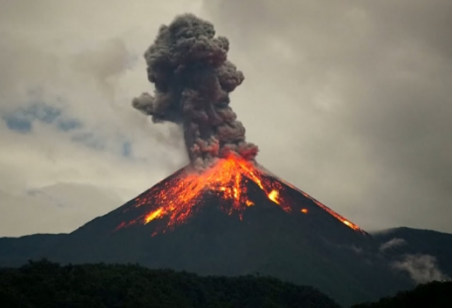

Peace and Safety – Johnny Baptist (10.)

Eccl 1:18

18 For in much wisdom is much grief,
And he who increases knowledge increases sorrow.
NKJV

Phil 4:4
Rejoice in the Lord always. Again I will say, rejoice!
NKJV

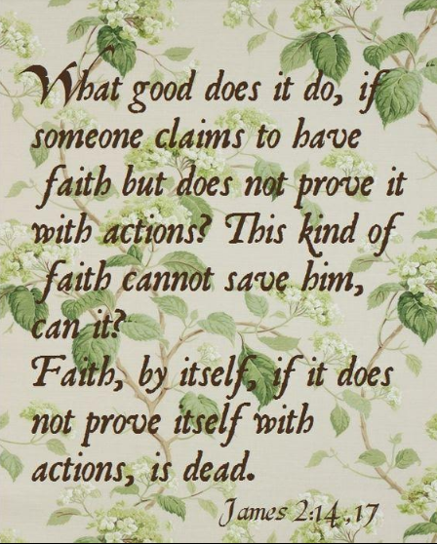

THE ANSWER TO THIS PROBLEM

Here is an exercise of amazing mathematical genius. Do you think you are up to it? How smart do you think you might be?
I challenge you to do the following.
Write a genealogy of Hebrew names in the Greek Language using the following rules.
- The number of words must be divisible by seven evenly
- The number of letters must be divisible by seven evenly
- The number of vowels must be divisible by seven evenly
- The number of consonants must be divisible by seven evenly
- The number of words that begin with a vowel, divisible by seven
- The number of words that begin with a consonant, divisible by seven
- The number of words that occur more than once, divisible by seven
- The number of words that occur in more than one form, divisible by seven
- The number of words that occur in only one form, divisible by seven
- The number of nouns, divisible by seven
- Only seven words, shall not be nouns
- The number of names, divisible by seven
- Only seven other kinds of nouns may be used
- The number of “male names”, divisible by seven
- The number of generations, divisible by seven

This is Matthew Chapter One – Verses 1 – 11

THIS IS THE GENEALOGY OF YOUR KING
JESUS CHRIST

SMITH WIGGLESWORTH

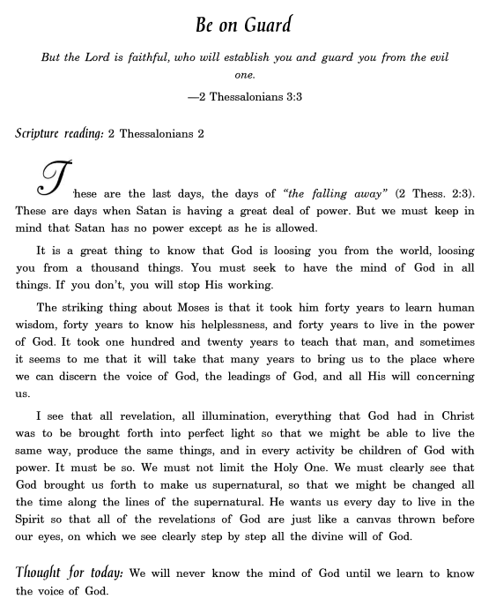
"A Prayer for Spiritual Revival":

Disturb us, Lord, to dare more boldly, To venture on wider seas Where storms will show your mastery; Where losing sight of land, We shall find the stars. We ask You to push back The horizons of our hopes; And to push into the future In strength, courage, hope, and love. Because we have dreamed too little, When we arrived safely Because we sailed too close to the shore. Disturb us, Lord, when With the abundance of things we possess We have lost our thirst For the waters of life; Having fallen in love with life, We have ceased to dream of eternity And in our efforts to build a new earth, We have allowed our vision Of the new Heaven to dim. Amen.
Sir Francis Drake
(1540 - 1596)

OPENING
There is nothing that makes us love a man so much as praying for him."
- William Law

Wisdom from Oswald Chambers
The remarkable thing about fearing God is that when you fear God you fear nothing else, whereas if you do not fear God you fear everything else. “Blessed is every one that feareth the Lord”
The Highest Good—The Pilgrim’s Song Book, 537

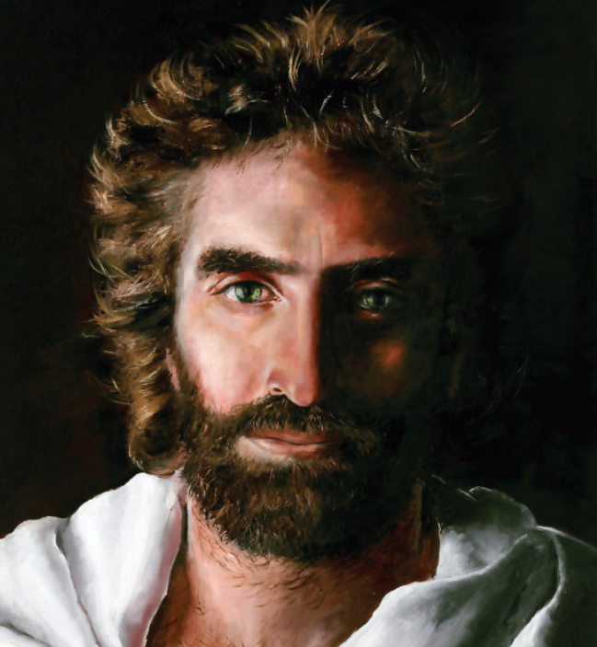

TURN YOUR EYES UPON JESUS
(short harmonic)
Zz – Just As I Am (Eden’s Bridge)
Zz – Oceans (Hillsong United)
Intermission – How Great Thou Art
Intermission – Exalted
Intermission – Praise Adonai

William Booth

“Not called!' did you say?
'Not heard the call,' I think you should say.
Put your ear down to the Bible, and hear Him bid you go and pull sinners out of the fire of sin. Put your ear down to the burdened, agonized heart of humanity, and listen to its pitiful wail for help. Go stand by the gates of hell, and hear the damned entreat you to go to their father's house and bid their brothers and sisters and servants and masters not to come there. Then look Christ in the face — whose mercy you have professed to obey — and tell Him whether you will join heart and soul and body and circumstances in the march to publish His mercy to the world.”
― William Booth

William Booth

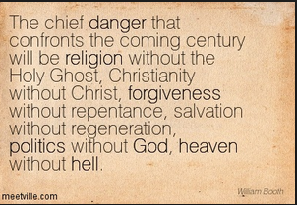

General William Booth TRY TEARS -
On April 9,1865, Lee met Grant in the parlor of a private home at Appomattox Court House. He surrendered his army and brought an end to four long years of death and devastation called the Civil War. In the same year a 36 year old Englishman by the name of William Booth declared war on the powers of darkness by founding the Salvation Army.
One of the most effective weapons in General Booth's arsenal was fervent prayer. It was not unusual for Booth to hold "an all night of prayer" when he came to preach the Word of God. People would flood the altars every where he went. "The power of God was wonderfully manifest in the meetings . . . people were frequently, struck down, overwhelmed with a sense of
the presence and power of God."
The Salvation Army's success at freeing the captives was uncanny, especially when one considers those who it strived to reach. General Booth's battle cry was "Go for souls and go for the worst." The worst of sinners were saved, saloons were closed and entire cities were shaken.

Booth's success attracted not only supporters but also enemies. Those who served in the Army were pelted with hot coals, sprayed with tar and burning sulphur, beat, stoned and even kicked to death in the streets. The Salvation Army resisted their enemies with a cheerful "God bless you", and a prayer. General Booth, himself was often in the thick of it. When spit on during the Midlands tour, Booth encouraged his fellow soldiers, "Don't rub it off - it's a medal!"
Night after night Booth would come home bleeding and bruised after being attacked for preaching in the slums of England. After such nights of testing he would take his wife's hand and say, "Kate, let me pray with you." After praying with Catherine he would rise from his knees armed with fresh courage and hope. Booth needed all the valor his wife Catherine could inspire
in him. She encouraged him, "if we get tired we had better go and be done with, anything is better than a dead church." Despite the grinding pressures of the ministry the Booths had a happily united family. The General had nine children and loved to play and romp with them, especially in their favorite game of "Fox and Geese."
Once while traveling, General Booth's car was detained. He took advantage of the opportunity and exhorted some idle factory workers. He said, "some of you men never pray, you gave up praying long ago. But I'm going to say to you, won't you pray for your children that they may be different?" Within minutes 700 men knelt in silent prayer.
At another time, two Salvation Army officers set out to found a new work, only to meet with failure and opposition. Frustrated and tired they appealed to the General to close the rescue mission. General Booth sent back a telegram with two words on it, "TRY TEARS." They followed his advice and they witnessed a mighty revival.
During the course of William Booths ministry he traveled 5,000,000 miles and preached 60,000 sermons. God help us in this desperate and distracted day in which we live to heed the General's advice. "Work as if everything depended upon your work, and pray as if everything depended upon your prayer."
References Used:
"The General Next To God" by Richard Collier
"Deeper Experiences of Famous Christians" by James G. Lawson
"The Life of General William Booth" by H. Begbie
This article was taken from The Watchword, volume 24 by permission.
Visit the Heart of God Ministries.
From <http://www.evanwiggs.com/revival/portrait/booth.html>

Luke 18:1-8 (The Persistent Widow)
Then He spoke a parable to them, that men always ought to pray and not lose heart, 2 saying: "There was in a certain city a judge who did not fear God nor regard man. 3 Now there was a widow in that city; and she came to him, saying, 'Get justice for me from my adversary.' 4 And he would not for a while; but afterward he said within himself, 'Though I do not fear God nor regard man, 5 yet because this widow troubles me I will avenge her, lest by her continual coming she weary me.'"

6 Then the Lord said, "Hear what the unjust judge said. 7 And shall God not avenge His own elect who cry out day and night to Him, though He bears long with them? 8 I tell you that He will avenge them speedily. Nevertheless, when the Son of Man comes, will He really find faith on the earth?"
NKJV

1 Sam 12:23
far be it from me that I should sin against the Lord in ceasing to pray for you;
NKJV

MONOLOGUE & MAIL

MONOLOGUE
(optional)

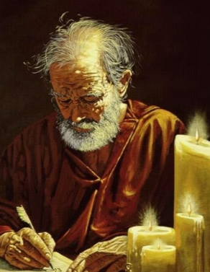
Phil 3:20-21
For our citizenship is in heaven, from which we also eagerly wait for the Savior, the Lord Jesus Christ, 21 who will transform our lowly body that it may be conformed to His glorious body, according to the working by which He is able even to subdue all things to Himself.

Phil 3:16-21 Our Citizenship is in Heaven

NKJV

Seals Events Timeline

WATCH LIST OF PROPHETIC JUDGMENT EVENTS

- Pacific North West Tsunamic Megaquake (Cascadia)
- Major California Earthquake (preceding Sixth Seal)
- Cosmic Object (asteroid) Hitting Sun Causing Solar Storm and Major Power Grid Outages
- Meteor Showers Causing Major Oil and Gas Fires
- Global Financial Collapse
- War North Korea, Sinking of US Aircraft Carrier
- Direct Missile Attacks and Foreign Troops on American Soil
- Israeli Jets Launch Tactical Nukes at Iran (Fordow)
- Major Man-Made Biological Attack, Pandemic Kills Millions
- Civil War and Unrest, Martial Law
- Libya Launches Nuclear Tipped Missile into Israel
- Gog / Magog Invasion Causes 2 Million in Israeli Losses
- Massive Increase in Volcanoes, Chaos, Mayhem, Riots
- Several Major US Cities Nuked (ground based)
- Russian, Chinese and North Korean Attacks on American Soil
- One or More Major Cataclysmic Events with Global Impact (Cosmic and Possible Earth Bound)
- Red Skies as a 24 Hour Warning Prior to the Meteor Hitting Atlantic
- METEOR STRIKE (opening Sixth Seal)
- Double Mega Tsunami Wiping Out East Coast of US and other countries

THIRD SEAL AND FOURTH SEAL
- Libya Nukes Israel (Psalms 83)
- Other Nukes (Missiles and Ground) (FOURTH SEAL; ‘on down’)
  - Israel -> Iran?
  - North Korea -> USA
  - Russia -> USA Cities Nuked from Ground
- Financial Collapse (THIRD SEAL)
- Chemical, Biological Attacks
- Disease, Riots, Chaos, Mayhem, Starvation
- EMP Attack (USA and Israel)
- Obama (attempts to) ratifies Israel Peace Deal Jerusalem Split
- (Possible) First Watch Rapture/Evacuation (See Luke 12:37-39; see TD Hale Nov 24, 2012 Dream – Streaks of Light)

SIXTH SEAL (Day of the Lord)
- Rodriguez Puerto Rico Meteor Slams Atlantic (SIXTH SEAL)
  - US Splits in Half (New Madrid)
  - East Coast Tsunami
  - California Megaquake (splits into ocean)
- Horrible Winter & Three Days Darkness
- Aliens Arrive (huge round mothership in the sky, seen worldwide)
- Harvest, Glory Light
- Final “RAPTURE” (Second/Third Watch? Luke 12:37-39)
- Final Nuclear Destruction (Babylon the Great)

THE GREAT TRIBULATION (God’s Wrath)
- FIRST TRUMPET – EARTH BURNS
- > The Rest of “The Great Tribulation” (God’s wrath)

https://youtu.be/M7a7RZZRLrsv

Owuor – War is Coming to South Korea (2017)

COOL STUFF
Lester Sumrall – I Ordered the Demons to Tell me Why they Returned

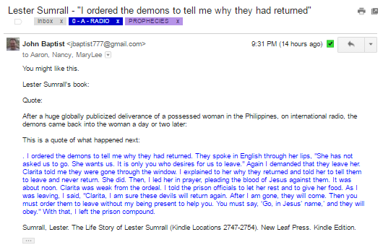

“There is nothing that makes us love a man so much as praying for him.”
― William Law
ALBERT PIKE WORLD WAR THREE

"The Third World War must be fomented by taking advantage of the differences caused by the "agentur" of the "Illuminati" between the political Zionists and the leaders of Islamic World. The war must be conducted in such a way that Islam (the Moslem Arabic World) and political Zionism (the State of Israel) mutually destroy each other. Meanwhile the other nations, once more divided on this issue will be constrained to fight to the point of complete physical, moral, spiritual and economical exhaustion…We shall unleash the Nihilists and the atheists, and we shall provoke a formidable social cataclysm which in all its horror will show clearly to the nations the effect of absolute atheism, origin of savagery and of the most bloody turmoil. Then everywhere, the citizens, obliged to defend themselves against the world minority of revolutionaries, will exterminate those destroyers of civilization, and the multitude, disillusioned with Christianity, whose deistic spirits will from that moment be without compass or direction, anxious for an ideal, but without knowing where to render its adoration, will receive the true light through the universal manifestation of the pure doctrine of Lucifer, brought finally out in the public view. This manifestation will result from the general reactionary movement which will follow the destruction of Christianity and atheism, both conquered and exterminated at the same time." ⁴

http://www.threeworldwars.com/albert-pike2.htm

THE PILGRIM CHURCH

The Pilgrim Church:
- A Second Century Letter to Diognetus

He writes “Christians are distinguished from other men neither by country, nor language”, living in such places “as the lot of each of them has determined, and following the customs of the natives in respect to clothing, food, and the rest of their ordinary conduct, they display to us their wonderful and confessedly striking method of life. They dwell in their own countries, but simply as sojourners. As citizens, they share in all things with others, and yet endure all things as if foreigners. Every foreign land is to them as their native country, and every land of their birth as a land of strangers…. They pass their days on earth, but they are citizens of heaven. They obey the prescribed laws, and at the same time surpass the laws by their lives… they are reviled and bless”. Then, speaking of God, he says, He, “who is almighty, the Creator of all things,… has sent from heaven, and placed among men, Him who is the truth, and the holy and incomprehensible Word, and has firmly established Him in their hearts.

- The Pilgrim Church

A Pastor’s Mansion
I saw a very gorgeous mansion, then a certain man was coming out, I knew he had been a pastor on earth. In heaven, they told me, the reason why he had a large and beautiful mansion in heaven, was primarily his giving & helping the needy and the poor, and his praying. These provided materials for his mansion in heaven.
They also explained to me, That different works we do on earth carry different weights in heaven, what God values and esteem high is very much different from what people think, they told me, the works we do that are unnoticed, behind the scenes, that people don’t know about and unappreciated are the works that God values more, the works we do out of a pure heart and selfless love, they have great reward in heaven. Then I saw it as GOD sees, what is really important to God, that we must not look for appreciating & reward from men but God, also God values what we do in private than what we do in public.
I looked over the City, the bright lights, the golden doors of mansions facing east, the majestic palace, the mansions and houses, the transparent streets of gold, the chariots travelling around, the children playing, saints talking and walking, the gardens, I said “Wow, Heaven is so wonderful”. I didn’t want to come back but I knew it was my time to go.

SEVEN KINGS
The Beast that Was, Is Not
OBAMA AND TRUMP

And there are seven kings: five are fallen, and one is(Obama), and the other is not yet come(trump); and when he cometh (Jan 20th), he must continue a short space. And the beast that was(president), and is not(no longer president), even he is the eighth(becomes president again), and is of the seven(previous presidents), and goeth into perdition.(becomes Antichrist)
Revelation 17:10-‬11 KJV‬‬‬‬‬‬‬‬‬‬‬‬‬‬‬‬‬‬‬‬‬‬‬‬‬‬‬‬‬‬‬‬‬‬‬‬‬‬‬‬‬‬‬‬‬‬‬‬‬‬‬‬‬‬‬‬‬‬‬‬‬‬‬‬‬‬‬‬‬‬‬‬‬‬‬‬‬‬‬‬‬‬‬‬‬‬‬‬‬‬‬‬‬‬‬‬‬‬‬‬‬‬‬‬‬‬‬‬‬‬‬‬‬‬‬‬‬‬‬‬‬‬‬‬‬‬‬‬‬‬‬‬‬‬‬‬‬‬‬‬‬‬‬‬‬‬‬‬‬‬‬‬‬‬‬‬‬‬‬‬‬‬‬‬‬‬‬‬‬‬‬‬‬‬‬‬‬‬‬‬‬‬‬‬‬‬‬‬‬‬‬‬‬‬‬‬‬‬‬‬‬‬‬‬‬‬‬‬‬‬‬‬‬‬‬‬‬‬‬‬‬‬‬‬‬‬‬‬‬‬‬‬‬‬‬‬‬‬‬‬‬‬‬‬‬‬‬‬‬‬‬‬‬‬‬‬‬‬‬‬‬‬‬‬‬‬‬‬‬‬‬‬‬‬‬‬‬‬‬‬‬‬‬‬‬‬‬‬‬‬‬‬‬‬‬‬‬‬‬‬‬‬‬‬‬‬‬‬‬‬‬‬‬‬‬‬‬‬‬‬‬‬‬‬‬‬‬‬‬‬‬‬‬‬‬‬‬‬‬‬‬‬‬‬‬‬‬‬‬‬‬‬‬‬‬‬‬‬‬‬‬‬‬‬‬‬‬‬‬‬‬‬‬‬‬‬‬‬‬‬‬‬‬‬‬‬‬‬‬‬‬‬‬‬‬‬‬
Revelation 17:10-11, King James Version (KJV)

THE DAY OF THE LORD

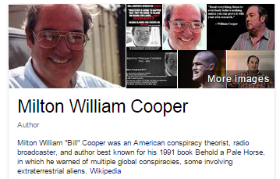

Amazingly Bill Cooper, the author of Behold a Pale Horse, made the following statement on page 177 of the book.
“Can you imagine what will happen if Los Angeles is hit with a 9.0 quake, New York City is destroyed by a terrorist-planted atomic bomb, World War III breaks out in the Middle East, the banks and stock markets collapse, Extraterrestrials land on the White House lawn, food disappears from the markets, some people disappear, the Messiah presents himself to the world, and all in a very short period of time? Can you imagine? The world power structure can, and will if necessary, make some or all of these things happen to bring about the New World Order.” [“Behold A Pale Horse“., p. 177-8]

The DAY OF THE LORD (more)

Johnny Baptist - Day of the Lord - GH7 Vision War of Worlds (14:35 mins)

Preview of the Day of the Lord

Subject: Barb God's Healer7 12-6-16 Preview of the Day of the Lord A foreshadowing Matt 24:27 Joel 1:15

Pt 1 Listen! The Lion Roars! The birds take flight. You can see the beasts of the earth running.
Look at the sky-it’s clear. Shhhhhh. Listen! I hear thunder. I know-How can there be thunder? the sky is clear.
I know, but it looks strange. Something’s not right. I have a peculiar feeling. Look over there-it looks like it’s
Lightning. I think we should go inside-it’s lightning and thundering to the east.

I’m going to put the news on to see if something is going on. The newsman says “the lightning and thunder can be
Heard and seen all over the world. The lightning is causing fires everywhere.”
What’s that? It looks like airplanes. I don’t know, but I can hear sirens. No, there is something else! Yes, I hear it.
It sounds like a trumpet blowing. Did you hear that???? The news says the government has ordered our planes up.
They are tracking something on the radar.
Let’s go down the street and look at the national guard armory. I can see the trucks coming up the road. I think we
Should go over to the store now. The local news just cut in and said the schools are all being let out early. All the national
Guard units are on alert. I’m going to stop at the bank first. Hurry up so we can get back before the kids come home.

Pt 2
We’d better hurry! The place looks jammed already. Put the news on. I can’t. The tv stations are all off the air.
I’ll try the radio. There’s nothing. It’s off the air too. I think I know what’s going on. Let’s get what we need and get home.
Look! None of the street lights are working. We will have to take the back roads. See if your cell phone works. No-it’s dead.

I can feel the earth shaking. Remember that earthquake we had? The doors were moving and the pictures. I think this is
What the Bible calls “the end of time” when Jesus returns, or The Day of the Lord. They say it will be a regular day.
No one knows when, but the signs are all available to see for those with eyes, and those with ears can hear the warnings.

I guess God gave warnings like He did in the time of Noah, and no one listened. They all laughed at the warnings.
God (?) made fun of it until it started to rain.
Guess what? I think it’s raining.
Barb adds:
That’s very intriguing. It’s a glimpse. It’s going to be a regular day. The Second Coming of Christ- no one is going to expect it,
Just like the Day of Noah. Everyone was just going about their regular business…
You know time is short when I’m getting a prophecy like this about The Day of the Lord and the Second Coming of Jesus.

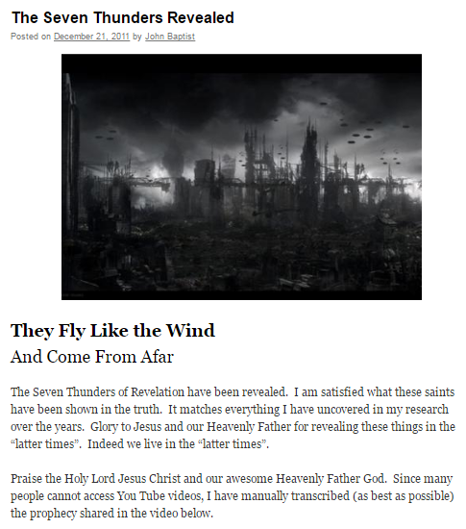

Godshealer7 – The Seven Thunders Revealed (short)
Godshealer7 – The Day of the Seven Thunders Draws Near (short)
Godshealer7 – All Will Hear What the Seven Thunders Uttered

The DAY OF THE LORD

Isa 13:1-16
The burden against Babylon which Isaiah the son of Amoz saw.
2 "Lift up a banner on the high mountain, Raise your voice to them; Wave your hand, that they may enter the gates of the nobles. 3 I have commanded My sanctified ones; I have also called My mighty ones for My anger — Those who rejoice in My exaltation."
4 The noise of a multitude in the mountains, Like that of many people! A tumultuous noise of the kingdoms of nations gathered together! The Lord of hosts musters The army for battle. 5 They come from a far country, From the end of heaven — The Lord and His weapons of indignation, To destroy the whole land.
6 Wail, for the day of the Lord is at hand! It will come as destruction from the Almighty. 7 Therefore all hands will be limp, Every man's heart will melt, 8 And they will be afraid. Pangs and sorrows will take hold of them; They will be in pain as a woman in childbirth; They will be amazed at one another; Their faces will be like flames.
9 Behold, the day of the Lord comes, Cruel, with both wrath and fierce anger, To lay the land desolate; And He will destroy its sinners from it. 10 For the stars of heaven and their constellations Will not give their light;The sun will be darkened in its going forth, And the moon will not cause its light to shine.
11 "I will punish the world for its evil, And the wicked for their iniquity; I will halt the arrogance of the proud, And will lay low the haughtiness of the terrible. 12 I will make a mortal more rare than fine gold, A man more than the golden wedge of Ophir. 13 Therefore I will shake the heavens, And the earth will move out of her place, In the wrath of the Lord of hosts And in the day of His fierce anger. 14 It shall be as the hunted gazelle, And as a sheep that no man takes up; Every man will turn to his own people, And everyone will flee to his own land. 15 Everyone who is found will be thrust through, And everyone who is captured will fall by the sword. 16 Their children also will be dashed to pieces before their eyes; Their houses will be plundered And their wives ravished.
NKJV

DESTRUCTION IS UNLEASHED
(Wings of Prophecy – Aliens)

WEDNESDAY, MAY 24, 2017
Destruction Unleashed

My children, as the destruction falls, you will see terrible things in your atmosphere. I desire to warn you of this so you will understand.
Destruction unleashed is something you have only glimpsed in make-believe. You have never truly seen destruction unleashed in your world and it shall be a terrifying sight. With destruction come many demonic entities that have heretofore been in another realm where you could not see them. These were not meant to dwell on the earth, but will be loosed for a season upon the wicked. You cannot kill these with weapons, and this, too, shall make you afraid, but you, My children, have the true weapons to keep them away from you – My Word, My Blood, and My Name.
This is part of why it is imperative you learn about Me now. You need these weapons and the knowledge of how to use each one stored up on your heart for that time, for it is not far into the future for you.
I forewarn you in My Mercy.

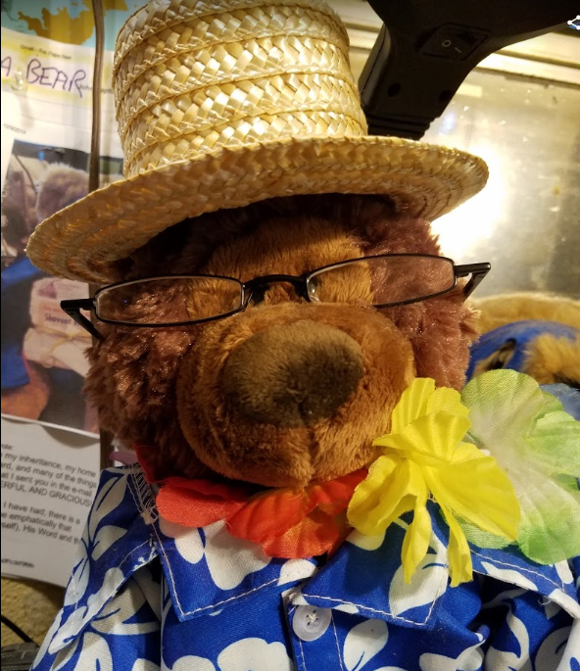

BLAST FROM THE PAST
- 00 – 00 Russian Submarine Song
- PLAY –Are We there Yet (Bongo Bear and Jezz)
- 03 - Don’t Worry Be Holy Johnny (FEMA Camps and Hidden Nukes)
- 02 – Johnny Baptist – I Don’t Wear Hawaiian Shirts All the Time

LOVE YOUR ENEMIES
32 'If you love those who love you, what benefit is that to you? For even sinners love those who love them.
33 And if you do good to those who do good to you, what benefit is that to you? For even sinners do the same.
34 And if you lend to those from whom you expect to receive, what credit is that to you? Even sinners lend to sinners, to get back the same amount.
35 But love your enemies, and do good, and lend, expecting nothing in return, and your reward will be great, and you will be sons of the Most High, for he is kind to the ungrateful and the evil.
36 Be merciful, even as your Father is merciful. (Luke 6 : 32-36 - ESV)
This text was sent on my Android phone or tablet.

PROPHECY RECAPS

THE MAN OF SIN - OBAMA

https://www.youtube.com/watch?v=9GG1skSwN_4&feature=em-uploademail

Godshealer7 - The Man of Sin will be Revealed for Who He Is (Obama)

Part 1 Daughter: speak this warning and tell the people what I have shown you. The restrainer will be taken away.
The man of sin will be revealed for who he really is-The Beast. Mr. Obama will return in his new position as ruler.
The streets will be filled with violence, civil unrest and war. The weak will be murdered, unable to defend themselves.
Children will murder parents for what they have and take it from them. Your militia will be unable to keep order or gain control.
There will be riots and fires. There will be no safe place. The unbelievers will rise to power. Behold, I come quickly.
Part 2 (after Barb prayed about the initial prophecy)
Abbara, you have seen well and have understood. This is The Tribulation coming upon the whole earth. Many will be killed
For My Names sake.

Barb then said she saw a glimpse of the “deep part” of the tribulation where children were killing their parents while she was receiving this prophecy.
Then Dan said this video might get GH7 taken off youtube, so this might be the last video from them.
Dan said he has received a portion of a Word in recent days: we are on the brink of “the time of trials”.
Dan then said they are criticized by some who say GH7 is just trying to stir up drama. Dan said they are just trying to prepare
People and get sinners to repent. Dan said he thinks we are right on the edge of something major.

SARAH MENET PROPHECY 1979
(Biological, Chemical, Nuke, Comets, a Year of Horror)
SARAH MENET PROPHECY
(Biological, Chemical, Nuke, Comets, a Year of Horror)
INTRODUCTION
As I tried to look away from my black surroundings, a small light started to shine in front of me, and the darkness, sounds and feelings that had so completely oppressed me started to fade into the background. The light grew bigger, and a window opened up much the same as when I had witnessed my life’s review. This time however, a panoramic view of the entire earth lay before me. It came closer and closer as if I had been out in space and was flying toward it.I knew what was happening was intended to help me make my decision about going back to the earth and my terrible life. A part of me wanted to go back to the beautiful spirit world, or paradise, that I had seen, and another part of me felt the need to be reunited with my body so I could change my life. It was a tug-of-war, and what I was about to see was to help me understand what I would be going through if I chose to go back to my ‘body of clay.’Again the view before me played out like a videotape in fast forward motion, and yet I could see the scene in perfect clarity and was able to comprehend everything that transpired.
IRAN (LYBIA) NUKES ISRAEL
As the earth zoomed up into my view, I first saw the whole world, and then various countries. It was made clear to me that in the future there would be wars and troubles, including nuclear attacks in various places of the world, and a view of how it would start was given.I am not familiar with the geography of the world, but as I looked a the various lands before my view I instinctively knew what countries they were. Looking at the Middle East, I watched as a missile flew from Libya and hit Israel. The mushroom cloud that resulted from the blast was visible, and I knew that the missile contained a nuclear bomb. I was aware that those responsible for the missile were Iranian, but the missile had been hidden and fired from within the borders of Libya.

OTHER NUCLEAR MISSILES FIRED
Almost immediately after this, other missiles began flying from one country to another, quickly spreading war around the world. I also saw that many nuclear explosions did not come from missiles but from bombs of some kind on the ground.

THE PRECURSOR EVENTS
EVENTS LEADING UP TO NUCLEAR WAR
My focus then changed from the Middle East to the United States, and I understood that I was about to see some of the things that would lead up to the nuclear holocaust that I had just witnessed.
SHE SEES 911 NYC
As I looked upon the continent of North America, I zeroed in on the eastern coast and then on New York specifically. I saw New York City with all of its people and buildings. I then saw some tall buildings crashing to the earth surrounded by tremendous amounts of smoke, dust, and debris.I zoomed in closer into the smoke and dust, and I saw a woman holding a little girl’s hand and running from the crashing buildings. The woman had long dark hair, hanging past her shoulders and curled inward slightly. She wore a beige business suit, heels of a slightly darker color, perhaps tan, and she was not wearing glasses. The little girl appeared to be about 6 or 7 years old with short brown hair reaching below the chin and cut in a type of pageboy look. They ran together, holding hands and trying to escape from the falling buildings. As they ran through the heavy smoke and dust, they were forced to let go of their hands and became separated. The child was terrified, and I could hear her screaming, “Mommy, mommy!” over and over again.I don’t know their outcome, if they lived or died, but I can still see the face of the woman clearly and could easily identify her from a photo or describe her to a sketch artist. I asked if an earthquake had caused the buildings to fall and felt impressed that the answer was no. However, I was not given any indication as to the cause of the destruction. (Incidentally, I told this story many, many times before September 11, 2001. When I did see on television the World Trade Center towers collapsing, I knew that this was what I had seen.

THIRD SEAL - FINANCIAL COLLAPSE
The next thing that came to me was more felt than seen. It was the understanding that shortly after the crashing of the buildings in New York City, commerce ceased. Shopping and buying seemed to stop, and the economy failed **throughout the world**. Few had any money at all, and those who did have it could not buy anything of worth with it. Gold and silver and other commodities had value and could be traded.
CHEMICAL ATTACKS
I then saw a man walk into a middle of a crowd of people and drop what seemed like a quart jar full of liquid. The jar broke and the liquid spread. I understood that people nearby had become infected with a disease from the liquid, and ***they didn’t even know it***.
A day or two later the people became sick and started dying. I saw that this would happen in four particular cities: New York, Los Angeles, San Francisco and Salt Lake City.
The disease started with white blisters, some the size of a dime, appearing the hands, arms and face of the victims. The blisters quickly developed into white puffy sores. Those with the disease would stumble around and fall over dead. Many died within a short time, perhaps 24 hours.
EBOLA
I also saw other people with a flu-like virus that spread more quickly than the first disease. The victims had blood coming from their nose, mouth, eyes, and ears. These people died even faster of this disease than the ones who had the first sickness.
DISEASE SPREADS MURDER MAYHEM
These diseases became wide-spread across the United States with hundreds of thousands infected.As the people were fleeing the cities in the hope of saving their lives, gangs were attacking them and killing them.
In the towns that were struck with disease there was chaos, with looting, rioting and murders involved in a complete breakdown of society. Many people seemed to go crazy.
EMP NO ELECTRICITY (US & ISRAEL)
I sensed that the electricity had failed everywhere and that nothing was running throughout the country, including any of the communication systems. I watched people throw rocks through windows to steal TV’s that would not work and thought it was very strange.
While I watched all this happening in the United States, my view instantly jumped back to the Middle East, and I saw the same thing taking place in Israel. The same sores and the same types of sickness and disease that were plaguing the U.S. had also been unleashed in Israel.The switch in view only lasted an instant, and I was back in the United States.
HORRIBLE WINTER
There was a tremendously long winter that caught everyone by surprise following the siege of sickness. It started early and lasted into the summer months. A famine had begun over the few years leading up to the long winter because of storms, droughts, floods and other plagues that had taken place; and the abnormally long cold period seemed to cause the famine to suddenly increase to its full measure.
In the period of time following the disease, which was quickly followed by the long winter, things started going down hill very quickly. Events piled up one on top of another without any breaks.
(SENSE OF TIMING OFF)
My sense of timing was not very clear at this moment; however because I was seeing several things happening all at the same time or very close together.
CHAOS, STARVATION, MAYHEM, CONTINUES
During and after the long winter, the disease spread everywhere and increased in severity. The economy and the electricity were completely gone. Chaos and anarchy reigned over the entire United States. Without any government there was a total breakdown, and I saw people panicking everywhere. They were trying in vain to find food. There was none. I saw people even digging in the ground for worms to eat because they were so hungry from the lack of food.Also, during this time I became aware that there was very little drinking water, and the remaining water had become contaminated, so that if a person drank it they would contract the disease and die. Because of their great thirst many people drank the water in spite of the danger of poisoning and died.I mentioned earlier the gangs that killed people trying to escape the cities. It seemed that some of the people had lost their minds and went around in these gangs killing people just for the sake of killing; others killed for food or to gain some material possessions from their victims. Those that were killing for no reason were like beasts: animals completely out of control, as they raped, looted, burned and butchered people. I saw these gangs go into the homes of those who were hiding. They would drag them out of their hiding places, rape and dismember them.For many there was an unnatural fear and hatred that came over the people. Family ties that once existed between husbands and wives, parents and children no longer mattered. The only thing that mattered was individual survival. Men would kill their wives and children for food or water. Mothers would kill their children. For me, the events that then lay before me were horrible beyond description and almost unbearable to watch.The air everywhere was filled with smoke as many buildings and cities burned with no attempt to control the fires.

HOMES/CITIES OF LIGHT & REFUGE
(ISAIAH 60:1-3)
(Glory Light)
As I looked upon this scene of chaos, smoke and destruction I noticed that there were small pockets of light scattered over the United States. There were, I would guess, about twenty or thirty of them that I saw. I noticed that most of the locations of light were in the western part of the United States, with only three or four of them being in the east. These places of light seemed to shine brightly through the darkness and were such a contrast to the rest of the scene that they caught my attention.
I focused on them for a moment and asked, ‘What are these things?’
I was then able to see that these points of light were people who had gathered together and were kneeling in prayer. The light was actually coming from the people, and I understood that the light was showing forth their goodness and love.
I further understood that they gathered together for safety and that, contrary to what I had witnessed everywhere, the cared more for each other than for themselves. Some of the groups were small with only a hundred people or so, but other groups consisted of what seemed to be thousands.I realized that many, if not all, of these places of light, or cities of light as I began to think of them, had somehow been established just before the biological attack, and that they were very organized. It was as if they had known what was coming and had prepared for it. I did not see who or what had organized them, but I did see many people struggling to reach them with nothing but what they could carry.
(ISAIAH 60:1-3)
The cities of light had food that others outside of those groups did not have, and within the cities of light food was readily shared with those who joined their groups. In these places there was peace and safety. The inhabitants were living in tents of all kinds, many of which were no more than blankets held up by poles. I noticed that the gangs made no threats on these groups and left them completely alone, choosing to pick on other targets and unprotected people, as many of the people in those cities had guns that they would use for self-defense. The gangs also preyed upon the people who were traveling, trying to reach the cities of light.
CITIES OF LIGHT MOVED OFTEN
As I looked upon them, I realized that these cities of light were temporary and that in a short time the people living within them would go to another place. I do not know where they were to go but seemed to think that they gathered in the mountains, to higher places.

BABYLON THE GREAT DESTROYED
FINAL NUCLEAR DESTRUCTION
As I was viewing the cities of light, my focus changed, and I became aware of missiles being launched and hitting U.S. cities. I watched as mushroom clouds started forming over many areas of the United States. Some of the clouds came from missiles that I knew were fired from Russia, and others were not from missiles at all, but from bombs that were already in the United States. These latter bombs had been hidden in trucks and in cars driven to certain locations and then detonated. I specifically saw Los Angeles, Los Vegas, and New York City hit with bombs. New York City was hit with a missile, but I think that Los Angeles was hit by at least one truck bomb, if not several, because I didn’t see any missile. I also saw a mushroom cloud from north of Salt Lake City, but without the aid of a missile.
SIXTH SEAL - FIRE BALLS & COMETS START FIRES
In the darkness I also saw little fireballs. I’m not sure if this happened just before or during the mushroom clouds. The balls fell from the sky, were of different sizes – most being the size of golf balls – and were very hot. There were millions of them. As they fell from the sky they left streaks of flame and smoke behind them. Everything they touched started on fire: people, buildings, trees, or grass. Everything burned. I didn’t ask what they were or where they had come from because by this time I was sick because of the scene before me, and so I observed without asking many questions.
RUSSIAN CHINESE INVADE
(part of nuclear war)
At almost the same time and in the same locations as the mushroom clouds, I saw Russian and Chinese troops invading the United States. The Russians were parachuting at many spots along the Eastern Coast; I also saw them parachuting in Utah. Chinese troops were invading from the West Coast near Los Angeles. They were met with resistance from those who had survived the disease and bombs. I did not see any United States military there at that time.The invasion was part of the nuclear war that I had seen earlier, and I knew that similar events were taking place all over the world as I had seen previously.
RUSSIAN CHINESE INVASION SHORT DURATION
I did not see much of this war, but was impressed that it was short in duration and the Russian and Chinese armies lost and left. No explanation regarding how or why was received.Now the smoke became very heavy, dark and thick.
GLOBAL MEGAQUAKES TSUNAMIS VOLCANOS, US SPLITS, MAYHEM
Just as things appeared to be as bad as they could get, the earth began to quake. This occurred during a winter, seemingly the winter that followed the very long one I had seen earlier. The chaos had existed for almost a full year by this time.
The earthquakes began in the west, around Idaho and Wyoming, and then quickly spread in every direction. I saw a huge earthquake hit Utah, and then California. There were earthquakes all over California, but they were especially devastating in the Los Angeles and San Francisco areas. San Francisco appeared to turn upside down.
The multiple earthquakes triggered volcanoes all over the west, and they started spewing a tremendous amount of ash and smoke into the air, causing it to become very dark and dirty and blocking much of what was left of the sunlight.There were also huge waves of water that swept over the west coast, and as I saw them I realized that this same thing was happening to coastal cities all over the world. The waves were so huge that Los Angeles was nearly swept away.I saw a wall of water taller than some of the buildings, perhaps as high as fifteen or twenty feet, sweep through Salt Lake City. I thought this was strange because of its location so far from the ocean, and wondered how a wave could travel all the way to Salt Lake City. I was impressed that the wave had not originated at the ocean, but was from under ground. I quickly noticed great cracks in the earth around Salt Lake City opened up and saw water shooting up out of the ground. I felt that deep under the ground was a huge amount of water and that the earthquakes had forced it up to the surface. Most of the buildings were swept away or destroyed when the water swept over the city. In fact there had been tremendous destruction, with only a few buildings left standing. The water coming from underground stretched from Idaho down to near Cedar City, Utah, and was very destructive.As I looked, I could see that cities all over the country had been devastated, and there was rubble everywhere. Most of the buildings were destroyed.
However, I realized that even though there was tremendous destruction from earthquakes, disease, floods, volcanoes, and tidal waves, the majority of the deaths were caused by the gangs of roving marauders that killed for pleasure.As I studied the scene for a moment, the thought occurred to me that the earth itself had become sickened at the terrible acts of cruelty that were happening upon it and was finally reacting through these natural disasters. The earth was attempting to cleanse itself of the chaos and evil that had engulfed the people.
The ash and smoke from the volcanoes had increased, and there was now almost complete darkness everywhere upon the earth.The diseases also increased in devastation, and I saw people literally dying on their feet. I saw another particular disease that started with red blotches, and then the victims would start to bleed from every opening in their bodies. Then the people literally disintegrated, or melted into unrecognizable masses of flesh and bone. The sight was horrendous, as death and the dead were everywhere.After this second terrible winter, I saw the survivors pile up the dead into huge piles to burn them. The stench was sickening. Some of the bodies had been burned during the time of chaos, but because people were more concerned with their survival they had mostly ignored the dead around them.
A huge earthquake occurred in the middle of the United States. It was tremendous and seemed to split the United States in half about where the Mississippi River is. The crack in the earth that resulted was huge, miles wide, and as it opened up the earth seemed to swallow everything. Water flowed in from the Gulf of Mexico all the way up to the Great Lakes. The Great Lakes did not exist any longer, however, as they became part of a large inland sea.
MEGAQUAKES WORLDWIDE
Then I saw another series of tremendous earthquakes all over the world. But they were not many, separate earthquakes, rather it was all part of one gigantic earthquake that shook the entire earth. Because of this earthquake waters overflowed their boundaries onto land all over the world. There were again huge walls of water along all of the coastal regions. This earthquake and the walls of water made the earlier ones seem small by comparison. I am not sure if the earthquake that split the United States in two was a part of this worldwide quake or not.
PLANET X, HUGE WHIRLWIND, PEOPLE HIDING IN ROCKS
(More Sixth Seal)
Next I saw a mighty wind come upon wind come upon the earth. As the wind hit, I saw people go into caves and into the cracks of rocks to try to escape its fury. It appeared to be stronger than any hurricane or tornado. It seemed that everything that had been left was now blown away.I understood, without asking, that the great worldwide earthquake and the mighty wind were somehow caused by a huge planet-like object, that had come very close to the earth and had disrupted everything. It was also made clear to me that it was very near the “end” when this happened.

FIRST TRUMPET (BURNING)
Now my perspective changed: I once again viewed the entire earth from a distance. I then saw a huge fireball, much larger than the earth, approaching our planet. It was extremely bright red and gold in color, and it engulfed the whole earth. When I witnessed this event I could not help but feel the difference between it and everything else that had occurred, and so I asked what this was that I saw. I was impressed that it was the burning of the earth that is described in the Bible.
RAPTURE JUST PRIOR TO FIRST TRUMPET
(pre-wrath)
I understood that just before the fireball’s appearance Jesus had appeared, and the good people I had seen earlier had left with Him and were no longer on the earth. The few people left behind were those wicked who had survived the earlier devastations. The picture of the earth engulfed by this huge ball of red and gold fire slowly faded away into blackness.
VISION ENDS
I was thinking that I have to go down and take care of my children so that they could be protected from the terrible things that were going to happen and then I don’t remember any more until I woke up in the hospital.”Thanks for taking a gander at all the news I have compiled here as always Stay Safe!
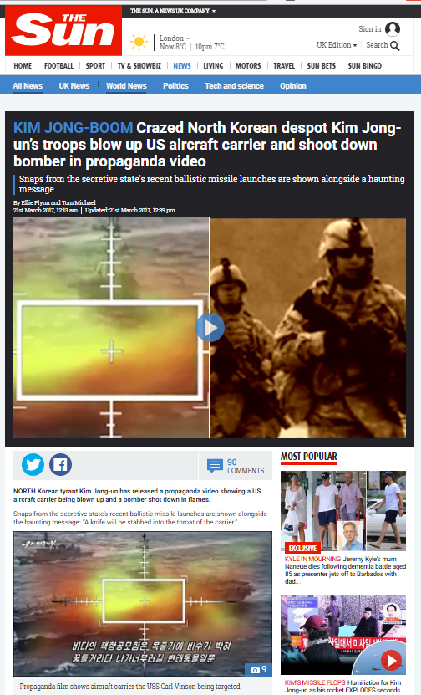
PROPHECY CONFIRM

Owuor – North Korea Missile Attack US Carrier S. Korea (3:19)

Godshealer7 – Vision US Naval Ship Bombing

NATHAN LEAL
Prophetic Alert – I Saw an Aircraft Carrier Sink
December 12, 2015
7545

Share on Facebook

Tweet on Twitter

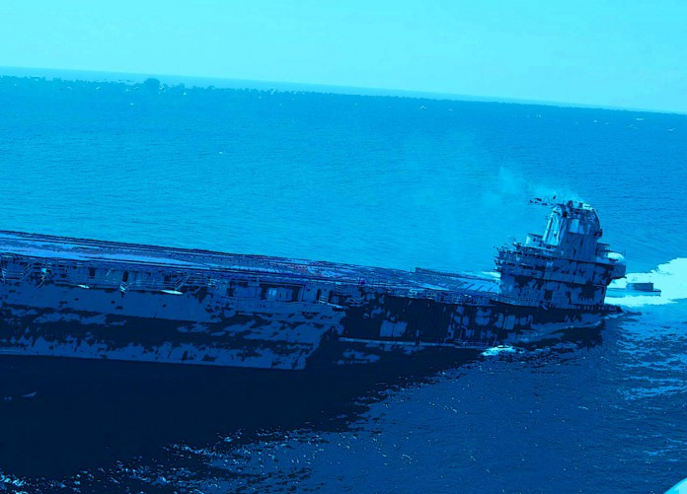
By Nathan Leal
(NOTE – I have posted a few reader comments at the bottom of this page.)
I am sending out this prophetic alert because God’s people need to pray. If you have followed this ministry for any length of time, you may know that it has a history of prophetic glimpses that have been shared over the years. Some have come to pass, some are in motion, and some are still in the delay of God’s mercy.
A few nights ago, I had another prophetic dream. It happened on December 5, 2015. I shared it that day with Doug Hagmann because I wanted to find insight on the meaning. After several days of holding onto it, I now feel prompted to share it with the brethren. Please take it under prayerful consideration. If anyone has insight on this information please let me know.
The Dream Begins
I was in the sky looking down and saw three aircraft carriers next to one another. I heard the words, “inland.” It could have been in a shipyard, but I am not certain.
As I watched the ships from above, one of them began to rotate counter-clockwise towards the left. The ground under the turning ship was very shallow. It scraped the earth under it while it rotated. I am not certain where the ship was located. It might have been at a port. (The ship could have been in a dry dock getting repaired, serviced, or it could have even been a brand new ship.)
After it rotated, the carrier left the port traveling south to southwest. When it reached “deeper water” (I heard the words – deeper water,) it began to sink.
It did not sink entirely, but it tilted which caused the end of the ship to begin submerging causing part of its platform to go underwater.

SOME WILL DIE EARLY
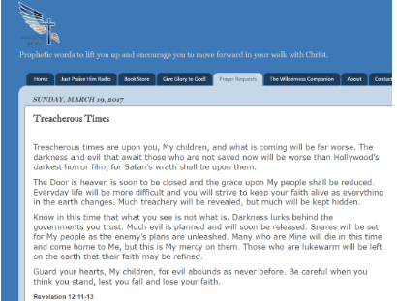

http://wingsofprophecy.blogspot.com/2017/03/treacherous-times.html?mc_cid=7720ccb8a2&mc_eid=a8b5c0097c
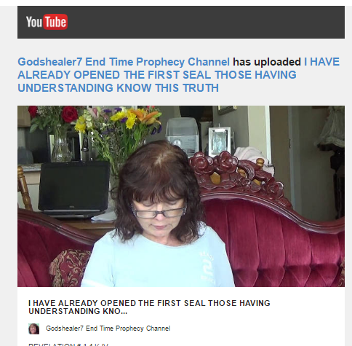
https://youtu.be/LRx7jXSabv0

GODSHEALER7 – I have already opened the 1st Seal, those with Understanding Know this Truth

Daughter, speak this message. Prophesy to the multitude, for I see many asleep. This is not the time to slumber. These are dangerous, perilous times. As was written, the foolish virgins are busy spreading lies and false stories to the sheep. Not called, they in turn repeat these stories, and pass along false information, lies, to anyone seeking a sign or word of knowledge. This will remove all hope and faith. Children, you must endure many trials. You will see tribulation. Do not be deceived by liars and sorcerers. Test all spirits. My Word is Truth. The time is later than worldly men and scholars believe. I have heard and seen their lies with My own ears and eyes! You now must discern the truth. The seals as opened will create great quakes on your earth. This is the truth. I have already opened the first seal. Those having wisdom, knowledge and understanding know this truth. ﻿

REJOICING IN JUDGMENT
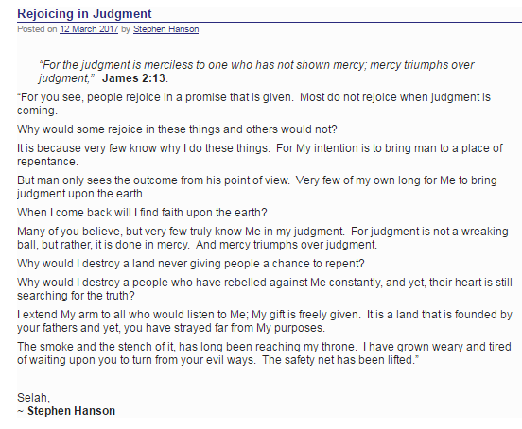

https://www.hiskingdomprophecy.com/rejoicing-in-judgment/

Two End time Open Visions
(By Ken Roman)

In the summer of 1956-57 I was walking along the sidewalk of my house and all of a sudden the entire atmosphere to my right became a blinding brilliant white. I was in New Jersey about 12 miles from NYC which was to my right. The intensity of this light was so all encompassing that it totally filled the entire eastern sky. Today I can say it was at least from the George Washington Bridge to the Statue of Liberty. I was young then and really did not know what I was seeing but I kept it to myself. Only several years later when I was participating in a US Navy NBC warfare class did I realize a brilliant white sky is what results after a hydrogen bomb.

In 1983 I was in a church service being held on the ORU campus and then while standing during the worship I saw a city like any major US City but it was such that there were no cars or any vehicles and there was no activity on the street or in the buildings that were there at all. What I saw was a line of people along the curb and they were missing legs, arms, eyes, feet, hands, and more. The next thing I saw was someone going down the line and praying for them and instantly there were now legs, arms, eyes, feet, hands, and other body deformities that were no more. What amazed me was the speed of this. I could not detect anything but a touch by the person and it was literally like Bing, Bing, Bing, that quickly! Then as the vision ended the Word of the Lord came to me and He said : "The Church started in the street and will end in the street"
To God Be the Glory.

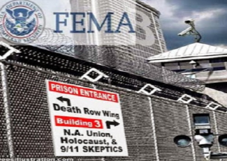

Sound Effect – Helicopter
Johnny Baptist – Helicopter, You are on the Red List, Come Out Now

SPECIAL PRIVILEGES TO THE
RIGHTEOUS WHO FEAR GOD

Ps 31:19
Oh, how great is Your goodness,
Which You have laid up for those who fear You, Which You have prepared for those who trust in You In the presence of the sons of men!
NKJV

Ps 11:5
5 The Lord tests the righteous,
But the wicked and the one who loves violence His soul hates.
NKJV

Ps 33:18-19
Behold, the eye of the Lord is on those who fear Him,
On those who hope in His mercy,
19 To deliver their soul from death,
And to keep them alive in famine.
NKJV

Ps 34:15
The eyes of the Lord are on the righteous,
And His ears are open to their cry.
NKJV

Ps 34:9
Oh, fear the Lord, you His saints!
There is no want to those who fear Him.
NKJV

Ps 34:17-18
17 The righteous cry out, and the Lord hears,
And delivers them out of all their troubles.
18 The Lord is near to those who have a broken heart,
And saves such as have a contrite spirit.
NKJV

IN CONTRAST

Ps 66:18
18 If I regard iniquity in my heart,
The Lord will not hear.
NKJV

Amazingly Bill Cooper, the author of Behold a Pale Horse, made the following statement on page 177 of the book.
“Can you imagine what will happen if Los Angeles is hit with a 9.0 quake, New York City is destroyed by a terrorist-planted atomic bomb, World War III breaks out in the Middle East, the banks and stock markets collapse, Extraterrestrials land on the White House lawn, food disappears from the markets, some people disappear, the Messiah presents himself to the world, and all in a very short period of time? Can you imagine? The world power structure can, and will if necessary, make some or all of these things happen to bring about the New World Order.” [“Behold A Pale Horse“., p. 177-8]

"A Prayer for Spiritual Revival":
Disturb us, Lord, to dare more boldly, To venture on wider seas Where storms will show your mastery; Where losing sight of land, We shall find the stars. We ask You to push back The horizons of our hopes; And to push into the future In strength, courage, hope, and love. Because we have dreamed too little, When we arrived safely Because we sailed too close to the shore. Disturb us, Lord, when With the abundance of things we possess We have lost our thirst For the waters of life; Having fallen in love with life, We have ceased to dream of eternity And in our efforts to build a new earth, We have allowed our vision Of the new Heaven to dim. Amen.
Sir Francis Drake
(1540 - 1596)

PREACHERS AND QUOTES

Link Angels
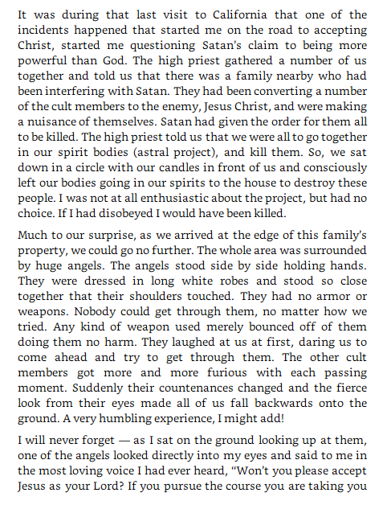
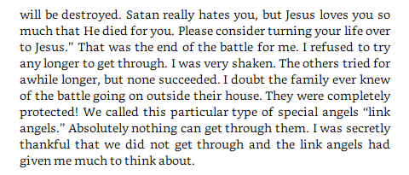

PRAYING THROUGH

What it means to Pray Through
Personal experiences in the availing and prevailing' intercessory ministry of Sister E. J. Dabney, as related in an interview and through letters to Sarah Foulkes Moore.
My first acquaintance with Sister Dabney was gained through letters which she sent to a friend from Norfolk, Va., describing the prayer revival which the Lord gave her in that southern city. These letters so stirred me that I made carbon copies of them and mailed them out to prayer group leaders in Los Angeles. AH who read the letters were given a new vision of what it really means to "pray through." Later, Sister Dabney came to Pastor Couche's Church at 33rd and Compton, Los Angeles, where in a prayer revival of a few weeks, God saved almost 200 souls and baptised as many with the Holy Ghost and fire.
Sister Dabney is a sister who makes prayer a business. If she sleeps at all, it is to be refreshed to resume her day and night vigils of prayer and waiting on God. She confines herself to one simple meal a day. She never indulges in any personal friendships, nor does she have light conversation with anyone. Usually she comes quietly to a meeting an hour before the time announced and begins to pray. When the meeting is over she slips quietly away to her room where her REAL ministry of travail for the deliverance of souls is carried on, far into the night.
In an interview Sister Dabney revealed how she came to enter this effective work for God and for souls. Her husband is a preacher. He was sent from a prosperous church in Philadelphia to labour in a poor one. At their first meeting no one was present but themselves. She saw it was going to be a difficult field for it was in the most wicked part of the city. She was made to know that nothing but prayer would touch the situation. She determined to give herself to prayer. She made a vow to God that if He would send sinners to that place and save them, she would give herself three days and three nights each week in the Church to prayer for three years. She vowed during two of these years to fast as well as pray. When she first told her husband of her intentions, he was unwilling to have her spend three days and nights each week in the mission alone in prayer. But the Lord made him to know it was of Him so he took her the next morning early to the river side where she knelt and made her vow unto the Lord.
As soon as this little wife of a hard-pressed minister began to pray alone in her husband's mission, God began to work. Sinners were sent in and soon their little hall was crowded out. Her husband asked her to pray for a larger place. God moved a merchant out of a nicer and larger building across the street and gave them this building. As she continued to pray day and night three days a week in her husband's new church it, too, was crowded out. Again her husband asked her to pray for a larger church. She did and God gave them a fine large church on a main boulevard in the same neighbourhood. Always the meetings were packed out and souls were delivered from sin and believers baptised in multitudes.
One morning at the church door as she was entering to keep her vow of prayer the Lord met her and said, "Go Home." But she did not want to go home. She wanted to pray. Then He asked her if she knew what day it was. She felt led to open her purse and read her vow and discovered from the date on the vow that she had exactly completed the three years she had given to God for prayer. Even though the Lord had shown her that her vow had been fulfilled, she wanted to go into the church and adore and worship Him, but He said again, "Go Home.''
She obeyed, everything about her seeming to praise and worship the Lord. When she got home the Lord drew her inside. Her soul was exalting in His Presence. Then He said to her "Go to the basement." She was afraid of the dark basement and hesitated. Why should the Lord ask her to go to such a place? She said, "Lord, if you are going to take me home to glory, first let me see my husband and son." She was afraid the Lord was going to take her home in the midst of all this rejoicing. But she put on perfectly new pumps and went to the basement. Instead of darkness it was filled with a wondrous light. Then the Lord spoke to her again and said, "You have prayed through. Now I have come to bless you.''
From the ceiling a fountain poured forth living water and this water rose higher and higher until it engulfed her. The joy and the presence of the Lord was so gloriously manifest to her that she began to dance. The Lord told her wherever she went and prayed He would deliver sinners from their sins, and fill believers with the Holy Spirit. She danced the heels and toes off her brand-new pumps.
This happened six years ago, and God has kept His word. Wherever Sister Dabney goes and gives herself to prayer, sinners are delivered and the saints are filled with the Holy Ghost and fire Thus the Lord mightily anointed her to pray. She does not preach but only counsels saints and sinners to seek the Lord till He is found. The following letters written in the midst of her prayer revival in Norfolk, Va., give an intimate insight into her life of prevailing prayer,
[12] AE vol. 7, no. 6, May 1941

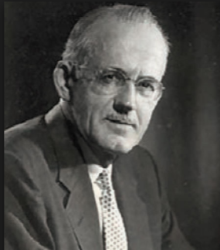
The yearning to know what cannot be known, to comprehend the incomprehensible, to touch and taste the unapproachable, arises from the image of God in the nature of man. Deep calleth unto deep, and though polluted and landlocked by the mighty disaster theologians call the Fall, the soul senses its origin and longs to return to its source

AW TOZER

Eyes of Faith
(Goiter Lady)
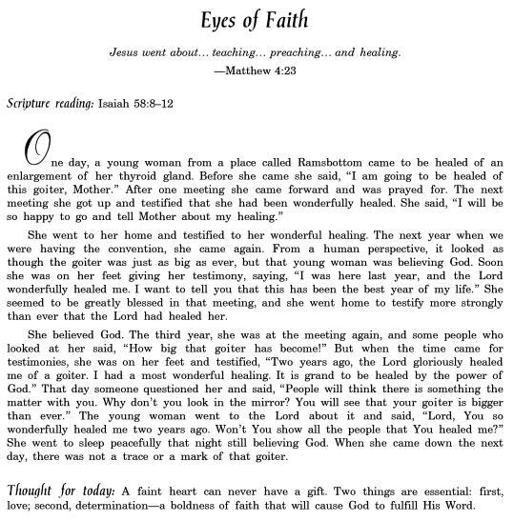

PROPHETIC WISDOM

"[A]bout the time of the end, in all probability, a body of men will be raised up, who will turn their attention to the prophecies, and insist upon their literal interpretation in the midst of much clamor and opposition.[65]"

- [65] Rev. J. W. Brooks “The Literalism Elements of rophetical Interpretation”. E. G. Dorsey, Printer.Philadelphia USA 1840. V. Preface. page VI

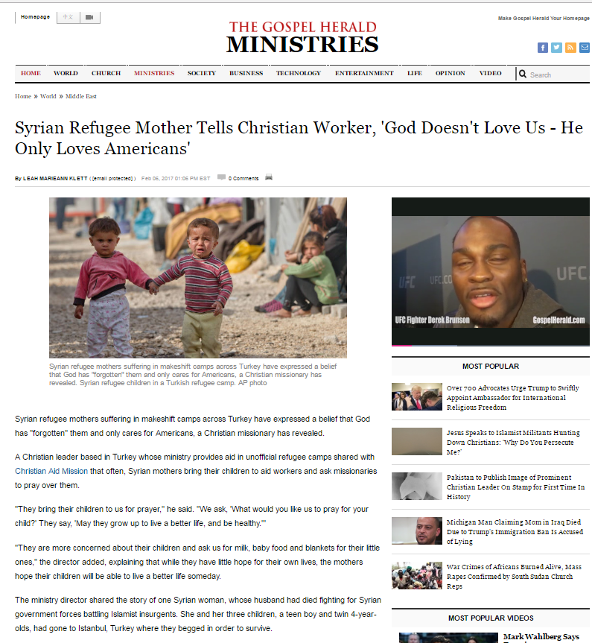
http://www.gospelherald.com/articles/69551/20170206/syrian-refugee-mother-tells-christian-worker-god-doesnt-love-us-he-only-loves-americans.htm
http://www.gospelherald.com/articles/60450/20151208/iran-now-has-one-of-fastest-growing-christian-population-as-more-muslims-are-having-dreams-and-visions-of-jesus.htm

INTENSIFIED PREVAILING PRAYER

Intensified prevailing prayer is God’s ordained law and method for implementing His redemptive plan in this age till Jesus returns. It is the highest, holiest, and mightiest effort of which a child of God is capable. It is God’s chosen way to bring heaven’s power, heaven’s resources, and heaven’s angels into action on earth. Spurgeon says, “He who knows how to overcome with God in prayer has heaven and earth at his disposal.” 1 Intensified prayer is clothed with the might of God Himself.

Duewel, Wesley L. (2013-08-20). Mighty Prevailing Prayer:

General Booth

“Not called!' did you say?
'Not heard the call,' I think you should say.
Put your ear down to the Bible, and hear Him bid you go and pull sinners out of the fire of sin. Put your ear down to the burdened, agonized heart of humanity, and listen to its pitiful wail for help. Go stand by the gates of hell, and hear the damned entreat you to go to their father's house and bid their brothers and sisters and servants and masters not to come there. Then look Christ in the face — whose mercy you have professed to obey — and tell Him whether you will join heart and soul and body and circumstances in the march to publish His mercy to the world.”
― William Booth

Humility in Daily Life
- Humility by Andrew Murray – Tribulation Now
(6 minutes)
If someone says, ‘I love God,’ but hates a Christian brother or sister, that person is a liar; for if we don’t love people we can see, how can we love God, whom we have not seen? (1 John 4:20) Here’s a sobering thought: God measures our love for Him by the love we show our brothers and sisters in every day fellowship with them. It is a serious thing to realize that our love for God just isn’t genuine if it fails the test of daily life with our fellow human beings. The same thing is true with humility. It is easy to think we humble ourselves before God. But humility before people is the only real proof that our humility before God is more than just a figment of our imagination. It is the only true evidence that humility has made a home in our hearts and become our nature. How can we know that we, like Christ, have made ourselves of no reputation? By the reality check of daily life. When in God’s presence humility has become more than just a feeling we have when we think about Him or pray, but instead the very
Spirit of our lives, it will show itself in the way we treat our brothers and sisters.

OSWALD CHAMBERS

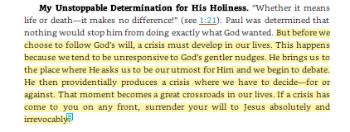

OSWALD CHAMBERS
Will You Go Without Knowing?

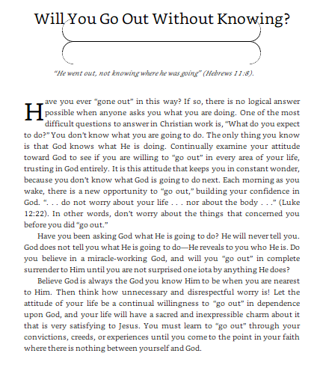
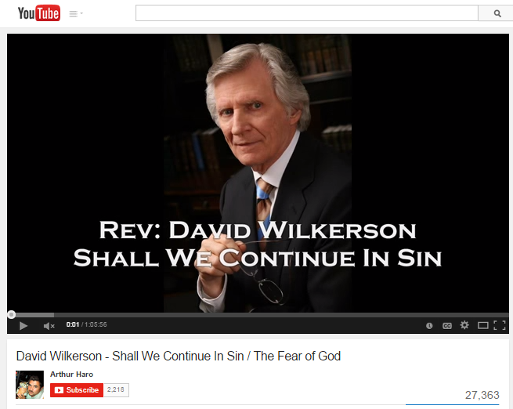https://www.youtube.com/watch?v=1uYCX4SYDUI

David Wilkerson – We Do Not FEAR God
https://www.youtube.com/watch?v=TDolHW7CfA4

Holy Desperation Wake Up Church (Short Pure Bride)

Holy Desperation – Wilkerson – I Don’t Care if You Like Me but I’m Going to Get Your Cancer Out

Holy Desperation – Carter Conlon – The Feet Coming Down the Hallway

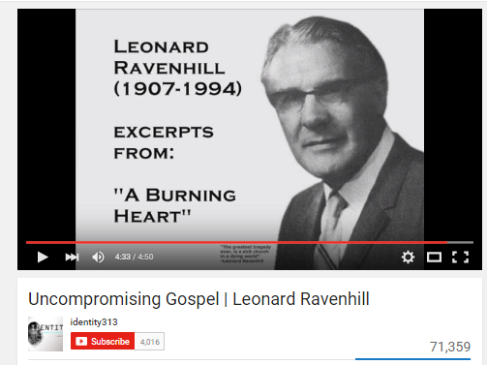

https://www.youtube.com/watch?v=2IoOgBxrwCo

Leonard Ravenhill – Uncompromising Gospel (4:50)

HOLY DECLARATIONS
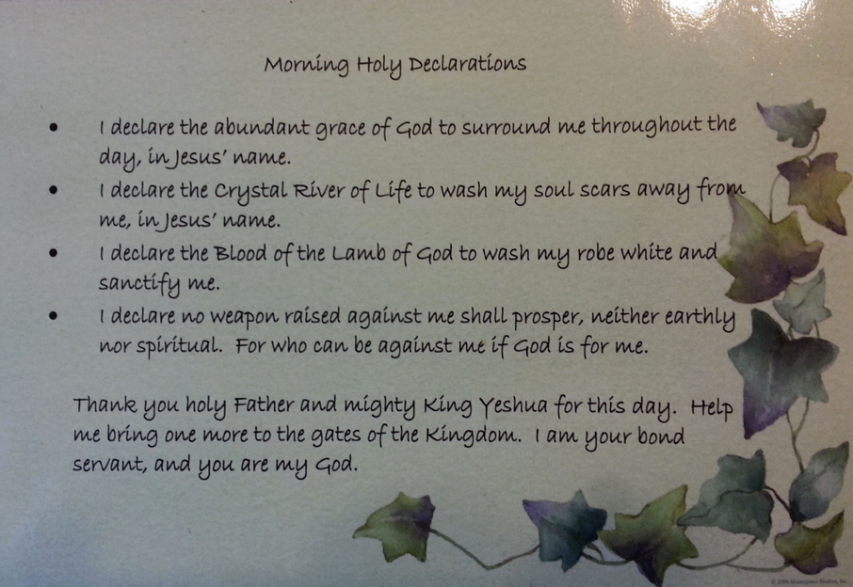
"I DECLARE the abundant grace of God to surround me throughout the day in Jesus name"
"I DECLARE the Crystal River of Life to wash my soul scars away from me in Jesus name"
"I DECLARE the blood of the Lamb of God to wash my robe white and sanctify me"
"I DECLARE no weapon raised against me shall prosper, neither earthly nor spiritual, for who can be against me if God is for me"
"Thank you holy Father and mighty king Yeshua for this day. Help me bring just one more to the gates of the Kingdom. I am your bond servant, you are my God

APOCALYPTIC BULLETS

http://youtu.be/w-0TEJMJOhk
PLAY - Apocalyptic Bullet Points w Weird Al George Carlin Foil Song (combined)
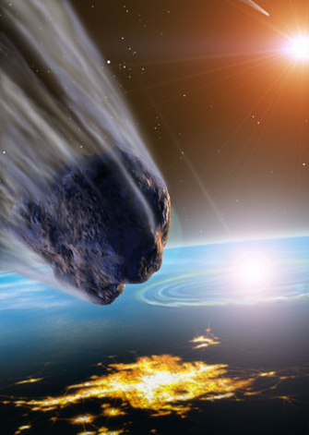

JESUS VICTORY STORIES

JESUS
VICTORY
STORIES

Amazing Growth China Underground Church
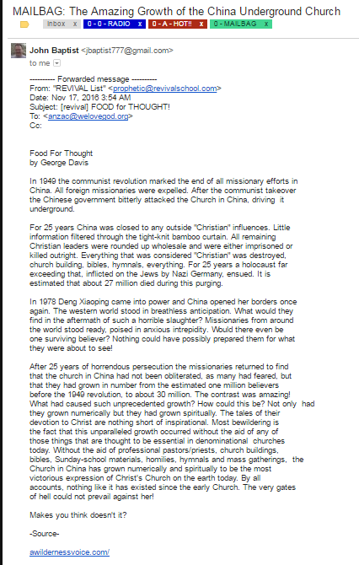

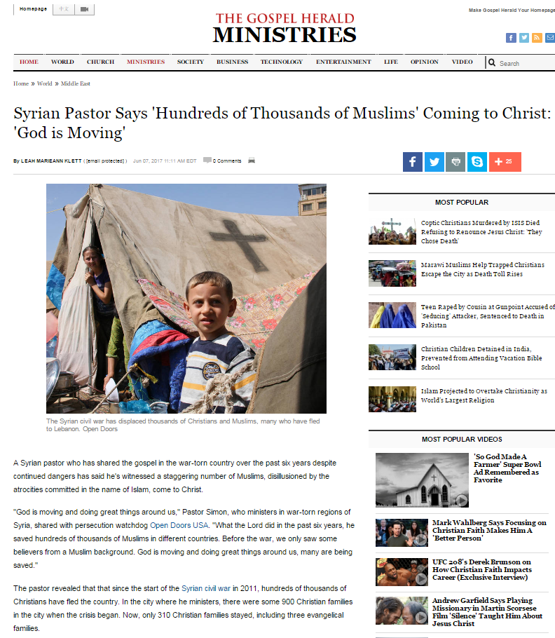
http://www.gospelherald.com/articles/70852/20170607/syrian-pastor-hundreds-thousands-muslims-coming-christ-god-moving.htm

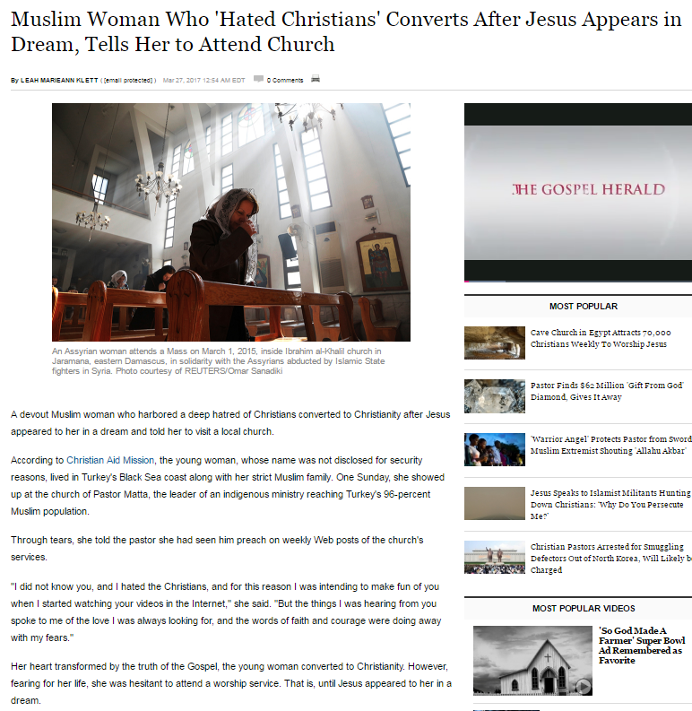

http://www.gospelherald.com/articles/69958/20170327/muslim-woman-who-hated-christians-converts-jesus-appears-dream-tells.htm
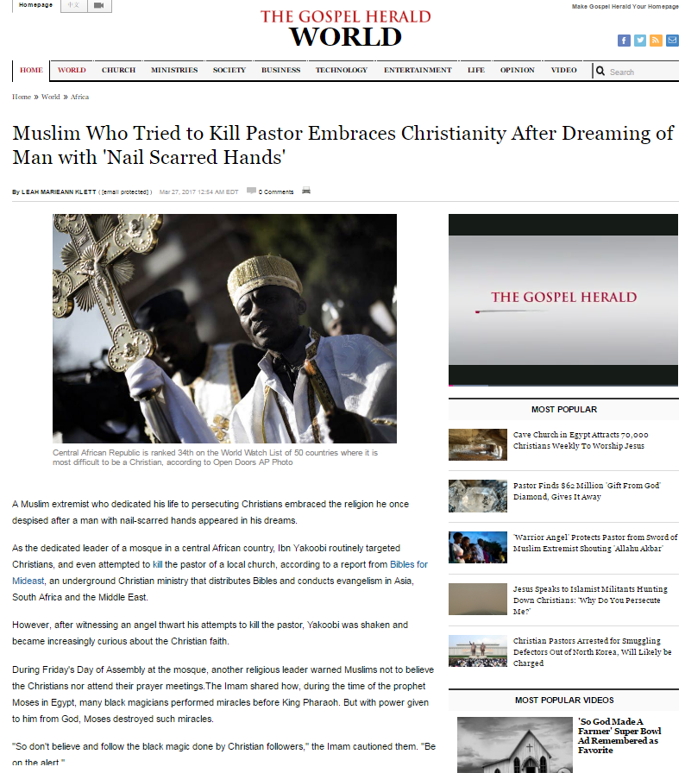

http://www.gospelherald.com/articles/69956/20170327/muslim-who-tried-kill-pastor-embraces-christianity-dreaming-man-nail.htm

http://www.gospelherald.com/articles/71099/20170710/powerful-shaman-embraces-christianity-deathbed-dreaming-man-brilliant-white-robe.htm

Sound Effect – Helicopter

MOVIES

PROPHETIC MOVIES
COMING UP

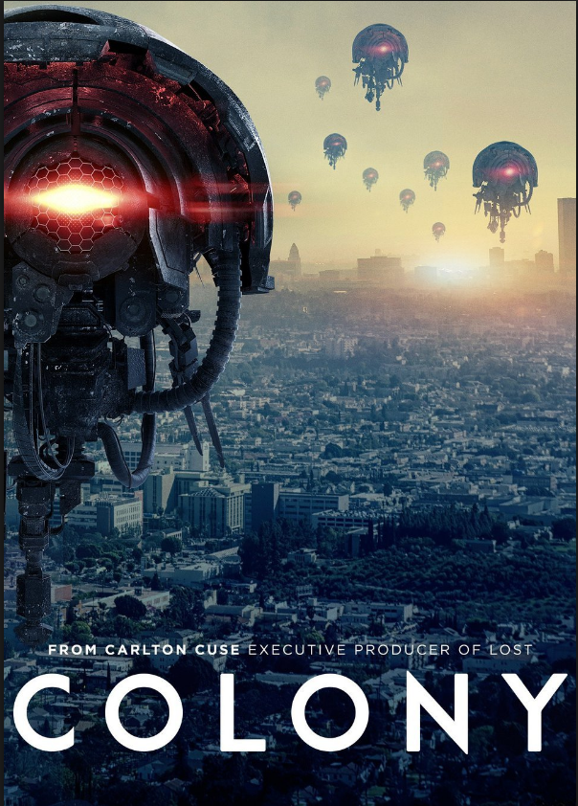
Because of an Attack on Our Capital
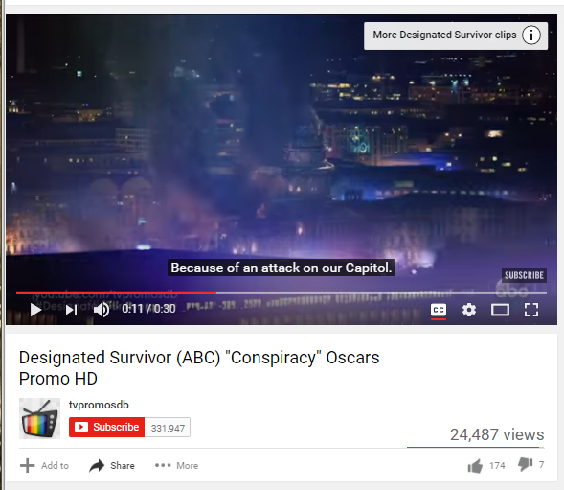
https://youtu.be/-XDedMlK2a8

Designated Survivor Commercial

JOHNNY BAPTIST – THE NEW WORLD ORDER
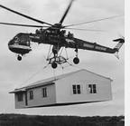

Johnny Baptist – Helicopter, You Are on the Red List, Come Out Now

TIMELESS

START WITH
SUN, MOON, STARS

NEW WORLD ORDER, VIOLENCE, UPHEAVAL, CHAOS AND RUMORS OF WARS

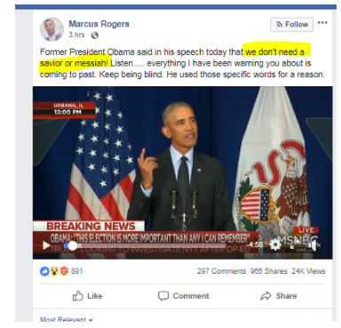

https://www.facebook.com/100000233350348/posts/2418737268144028/

OBAMA MSNBC State ‘You Don’t Need a Savior or Messiah’

http://www.breakingchristiannews.com/articles/display_art.html?ID=18058

ANOTHER HYPERCYCLE –
- THREE DAYS OF DARKNESS (Oct 31, 2018)
- NEW HYPERCYCLE 11.11

PROPHECIES

POPOCATEPETL, MEXICO CITY, VOLCANOES, FINANCIAL COLLAPSE
Vision of What’s Coming to America
Aug 13, 2012
Randy Hecker
spiritofprophecy.maxforum.org/
www.randyhecker.wordpress.com
Anyway here goes. The sequence I am watching (as a Watchman of the Lord) begins with Mt. Popocatepetl in Mexico. There will be a sudden very powerful eruption that will blow its lid off. Within hours an 8+ magnitude earthquake will strike Mexico City and virtually level it. Thousands will be killed. Hundreeds of thousands will be injured. And millions will be displaced from their homes. The economy of Mexico, bad as its, will collapse except for precious metal values. There will be anarchy throughout the land.
This event will radically increase pressure on the San Andreas Fault to the north. The fault is locked up in an area from Palm Springs in the south to Palm Dale to the north. HAARP will be used to create a super earthquake in this area. The magnified and duration n of the quake will both be magnified. The earthquake will strike (I believe) in the afternoon either this coming October or the following May. It will occur just after a complete economic meltdown of the American dollar. The magnitude of this quake will reach somewhere between 9.5 and 10.5 and it will last for nearly three minutes. Two to three million people will be killed outright. Millions more will be injured.
The worst part of this is not the earthquake itself but the events that will be associated with it. The ground shock from this quake will cause every other stressed fault within 1,500 to 2,000 miles to release all pent-up stresses. As the ground shockwave moves to the north the Sierra Nevada volcanoes will be triggered, the Cascadia volcanoes, and also the Yellowstone super volcano will also be triggered. This is both a blessing and a curse.
The nation will be so disorganized after this event that martial law will be declared , but it will be completely unenforceable.
Two to four days after this earthquake America will be further devastated a nuclear sneak attack on American cities, that will coordinated and started by our own Shadow Government. There will also be some Russia n and Chinese nukes as well. The world will very quickly descend into global thermonuclear war (Gog Magog war).

BLUE 21 ARTICLE
ELECTRICAL GRID GOES DOWN
1996 - DAVID DOUGERTY
http://www.fivedoves.com/letters/feb2009/davidd210.htm

By remembering these visions, it will or can save you much needless suffering.
The Lord does not want to hurt his bride.
The Appearance of a Large Sphere in the Sky
There is going to appear above the earth (in the sky) a strange object, it will be large and sphere shaped, like a ball. It will look like it’s been built in sections, like a football with huge rivets at the seams. Many will call this a UFO, I don’t know. It will have the color of copper or bronze. It will be on every TV around the world. People will be shocked like the World Trade Center. People will be glued to their TV’s but you don’t.
The minute you see this, run to the closest food store and get enough canned food and bottled water for about three weeks, because between one and 24 hours after this object is seen world wide there is going to be a massive impact or collision on our sun’s surface. It is going to happen on our blind side, we can’t see it coming. It’s going to be a super size twin asteroid hitting the sun in a vital spot, releasing a major solar storm, knocking out all of earth’s electricity, all over the world. Those of you who read this will save yourself and your family much misery.

2 to 3 Weeks of Trial and Miracles
Now, this is what’s going to happen in the next 2 or 3 weeks, while the electricity is off. Within a few days the whole world will start to go crazy with hunger. The banks and ATM’s can’t work without electricity. No gas pumps for food transportation, no refrigeration, total darkness. The robbers, rapists, and murderers will see right away that no one can call the police for help, because the solar storm has burned up all communication satellites, cell phones and telephones. The law can’t even call each other. It’s going to be total breakdown in large cities. There will be gun shots and screams all night long. Millions will be behind locked doors, praying and begging for God’s mercy, for help and protection. He will answer millions of prayers. Millions will ask for forgiveness, and the Lord and his saints will perform millions of miracles during these three weeks.
3 Weeks Later “The Rapture”
Then after about 3 weeks of this, the Rapture will happen. Although there are different time zones around the world, the Lord showed it will be night here in Florida, USA. In this vision, I was taken in the spirit out in the woods behind my house in Florida.

Seals Events Timeline

WATCH LIST OF PROPHETIC JUDGMENT EVENTS

- Pacific North West Tsunamic Megaquake (Cascadia)
- Major California Earthquake (preceding Sixth Seal)
- Cosmic Object (asteroid) Hitting Sun Causing Solar Storm and Major Power Grid Outages
- Meteor Showers Causing Major Oil and Gas Fires
- Global Financial Collapse
- War North Korea, Sinking of US Aircraft Carrier
- Direct Missile Attacks and Foreign Troops on American Soil
- Israeli Jets Launch Tactical Nukes at Iran (Fordow)
- Major Man-Made Biological Attack, Pandemic Kills Millions
- Civil War and Unrest, Martial Law
- Libya Launches Nuclear Tipped Missile into Israel
- Gog / Magog Invasion Causes 2 Million in Israeli Losses
- Massive Increase in Volcanoes, Chaos, Mayhem, Riots
- Several Major US Cities Nuked (ground based)
- Russian, Chinese and North Korean Attacks on American Soil
- One or More Major Cataclysmic Events with Global Impact (Cosmic and Possible Earth Bound)
- Red Skies as a 24 Hour Warning Prior to the Meteor Hitting Atlantic
- METEOR STRIKE (opening Sixth Seal)
- Double Mega Tsunami Wiping Out East Coast of US and other countries

THIRD SEAL AND FOURTH SEAL
- Libya Nukes Israel (Psalms 83)
- Other Nukes (Missiles and Ground) (FOURTH SEAL; ‘on down’)
  - Israel -> Iran?
  - North Korea -> USA
  - Russia -> USA Cities Nuked from Ground
- Financial Collapse (THIRD SEAL)
- Chemical, Biological Attacks
- Disease, Riots, Chaos, Mayhem, Starvation
- EMP Attack (USA and Israel)
- Obama (attempts to) ratifies Israel Peace Deal Jerusalem Split
- (Possible) First Watch Rapture/Evacuation (See Luke 12:37-39; see TD Hale Nov 24, 2012 Dream – Streaks of Light)

SIXTH SEAL (Day of the Lord)
- Rodriguez Puerto Rico Meteor Slams Atlantic (SIXTH SEAL)
  - US Splits in Half (New Madrid)
  - East Coast Tsunami
  - California Megaquake (splits into ocean)
- Horrible Winter & Three Days Darkness
- Aliens Arrive (huge round mothership in the sky, seen worldwide)
- Harvest, Glory Light
- Final “RAPTURE” (Second/Third Watch? Luke 12:37-39)
- Final Nuclear Destruction (Babylon the Great)

THE GREAT TRIBULATION (God’s Wrath)
- FIRST TRUMPET – EARTH BURNS
- > The Rest of “The Great Tribulation” (God’s wrath)

Prophetic Warning From David Wilkerson – Earth Shattering Word As God’s Judgment Comes To America

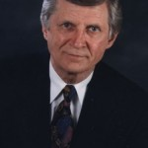
By DAVID WILKERSON – March 7, 2009
I am compelled by the Holy Spirit to send out an urgent message to all on our mailing list, and to friends and to bishops we have met all over the world.
AN EARTH-SHATTERING CALAMITY IS ABOUT TO HAPPEN. IT IS GOING TO BE SO FRIGHTENING, WE ARE ALL GOING TO TREMBLE – EVEN THE GODLIEST AMONG US.
For ten years I have been warning about a thousand fires coming to New York City. It will engulf the whole megaplex, including areas of New Jersey and Connecticut. Major cities all across America will experience riots and blazing fires such as we saw in Watts, Los Angeles, years ago.
There will be riots and fires in cities worldwide. There will be looting including Times Square, New York City. What we are experiencing now is not a recession, not even a depression. We are under Gods wrath. In Psalm 11 it is written,
If the foundations are destroyed, what can the righteous do? (v. 3).
God is judging the raging sins of America and the nations. He is destroying the secular foundations.
The prophet Jeremiah pleaded with wicked Israel, God is fashioning a calamity against you and devising a plan against you. Oh, turn back each of you from your evil way, and reform your ways and deeds. But they will say, Its hopeless! For we are going to follow our own plans, and each of us will act according to the stubbornness of his evil heart (Jeremiah 18:11-12).
In Psalm 11:6, David warns, Upon the wicked he will rain snares (coals of fire) fire burning wind will be the portion of their cup. Why? David answered, Because the Lord is righteous (v. 7). This is a righteous judgment just as in the judgments of Sodom and in Noahs generation.
WHAT SHALL THE RIGHTEOUS DO? WHAT ABOUT GODS PEOPLE?
First, I give you a practical word I received for my own direction. If possible lay in store a thirty-day supply of non-perishable food, toiletries and other essentials. In major cities, grocery stores are emptied in an hour at the sign of an impending disaster.
As for our spiritual reaction, we have but two options. This is outlined in Psalm 11. We flee like a bird to a mountain. Or, as David says, He fixed his eyes on the Lord on his throne in heaven his eyes beholding, his eyelids testing the sons of men(v. 4). In the Lord I take refuge (v. 1).
I will say to my soul: No need to run…no need to hide. This is Gods righteous work. I will behold our Lord on his throne, with his eye of tender, loving kindness watching over every step I take trusting that he will deliver his people even through floods, fires, calamities, tests, trials of all kinds.
Note: I do not know when these things will come to pass, but I know it is not far off. I have unburdened my soul to you. Do with the message as you choose.
God bless and keep you,
In Christ,
DAVID WILKERSON

POPOCATEPETL, MEXICO CITY, VOLCANOES, FINANCIAL COLLAPSE
Vision of What’s Coming to America
Aug 13, 2012
Randy Hecker
spiritofprophecy.maxforum.org/
www.randyhecker.wordpress.com
Anyway here goes. The sequence I am watching (as a Watchman of the Lord) begins with Mt. Popocatepetl in Mexico. There will be a sudden very powerful eruption that will blow its lid off. Within hours an 8+ magnitude earthquake will strike Mexico City and virtually level it. Thousands will be killed. Hundreeds of thousands will be injured. And millions will be displaced from their homes. The economy of Mexico, bad as its, will collapse except for precious metal values. There will be anarchy throughout the land.
This event will radically increase pressure on the San Andreas Fault to the north. The fault is locked up in an area from Palm Springs in the south to Palm Dale to the north. HAARP will be used to create a super earthquake in this area. The magnified and duration n of the quake will both be magnified. The earthquake will strike (I believe) in the afternoon either this coming October or the following May. It will occur just after a complete economic meltdown of the American dollar. The magnitude of this quake will reach somewhere between 9.5 and 10.5 and it will last for nearly three minutes. Two to three million people will be killed outright. Millions more will be injured.
The worst part of this is not the earthquake itself but the events that will be associated with it. The ground shock from this quake will cause every other stressed fault within 1,500 to 2,000 miles to release all pent-up stresses. As the ground shockwave moves to the north the Sierra Nevada volcanoes will be triggered, the Cascadia volcanoes, and also the Yellowstone super volcano will also be triggered. This is both a blessing and a curse.
The nation will be so disorganized after this event that martial law will be declared , but it will be completely unenforceable.
Two to four days after this earthquake America will be further devastated a nuclear sneak attack on American cities, that will coordinated and started by our own Shadow Government. There will also be some Russia n and Chinese nukes as well. The world will very quickly descend into global thermonuclear war (Gog

THE ALIEN SHIP BARLEY HARVEST

NOSTRADAMUS UFO IN THE SKY STARTS WWIII

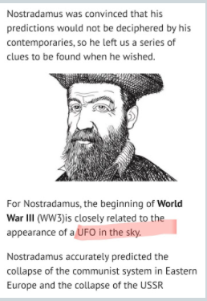
10 YR OLD JEREMY VISION OF WW3

“Future Events – World War III”
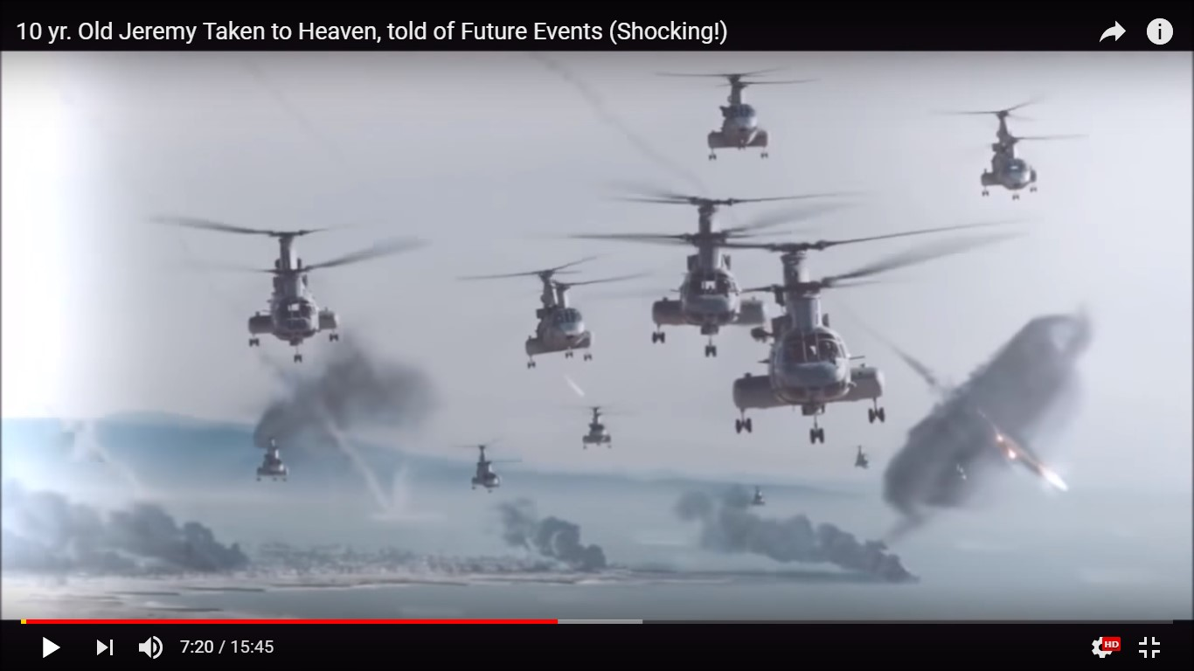
UFOs and aliens from other planets attack the Earth
The 10-year-old Jeremy and his Vision of Armageddon
Jeremy had a near-death experience when he was 10 years old.
For 40 minutes Jeremy was taken to heaven and upon returning to earth he told about difficult times in the future. After he went to heaven for the last time his story was told by his mother. But everything the boy has told about the future concerns Armageddon and that is not particularly reassuring. It is terrible!
The ultimate future
Many people believe that aliens exist. But what if the aliens are actually disguised demons? This is what the boy said to his mother before he died when he was 13 years old.
The boy spoke about the ultimate future of the earth. He said that the world war will begin first among mankind.
His mother continued to emphasize various details about the incredible experiences of her son.
What her son could see was the first day of the slaughter – when evil groups of demons will consume humanity, one at a time. People will be eaten by the invading group of demonic forces (aliens) who are extraterrestrial.
Disguised evil spirits
Some Christians suspect that aliens and UFOs have a demonic origin. Evil spirits could pretend to be as extraterrestrial beings. Kidnappings by aliens or Ufonauts could take place immediately after the Rapture. In the “Valley of Armageddon” these are demons and aliens, the army of Satan.
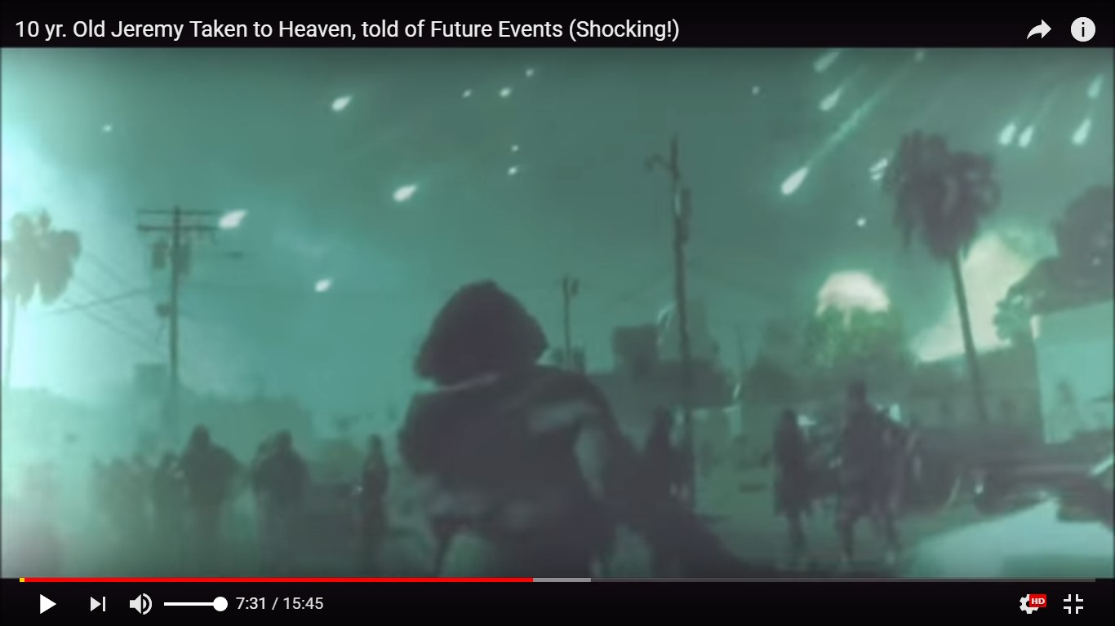
Attack from space by UFOs and spaceships
Demonic aliens
The images in the video are very realistic with what Armageddon will bring to people.
It starts at 6:45 where Jeremy’s mother begins to speak about a war that will spread throughout the world and can not be compared to any other war.
People are worried about the 3rd WW. But that is not what people have to worry about. There will soon occur something terrible and it is very evil. It is an invasion of aliens and demons and they are at war with the people on Earth. It is a huge army!

http://www.dezonengods.com/the-10-year-old-jeremy-and-his-vision-of-armageddon/

SISTER BARBARA – GH7 INTERSTELLAR ALIEN WAR

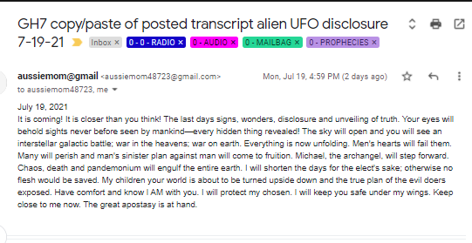

DAVID DAUGHTREY RAPTURE VISION 1996

The Rapture Vision of 1996
(Originally Published on Five Doves)
The coming events or warnings to happen just before the rapture takes place.
Dearly beloved doves, and brothers and sisters in Jesus name. This is the vision given in 1996 concerning world wide events to happen from one to three weeks before the actual Rapture. This I told to many friends, and was often hurt at the disbelief, and cold shoulders of many Christian friends that I finally just put it on the back shelf, and let it sit for the last 13 years.
I now feel that the Rapture is so close that it needs to be told, urgently. I agree with our Christian brother John Tng that there has been so many dreams and visions of the Rapture that probably no one will believe this one either, but that is okay. All I pray for is everyone to remember. Like our Bible says, the vision will prove itself with time and testing. By remembering these visions, it will or can save you much needless suffering.
The Lord does not want to hurt his bride.
The Appearance of a Large Sphere in the Sky
There is going to appear above the earth (in the sky) a strange object, it will be large and sphere shaped, like a ball. It will look like it’s been built in sections, like a football with huge rivets at the seams. Many will call this a UFO, I don’t know. It will have the color of copper or bronze. It will be on every TV around the world. People will be shocked like the World Trade Center. People will be glued to their TV’s but you don’t.
The minute you see this, run to the closest food store and get enough canned food and bottled water for about three weeks, because between one and 24 hours after this object is seen world wide there is going to be a massive impact or collision on our sun’s surface. It is going to happen on our blind side, we can’t see it coming. It’s going to be a super size twin asteroid hitting the sun in a vital spot, releasing a major solar storm, knocking out all of earth’s electricity, all over the world. Those of you who read this will save yourself and your family much misery.
2 to 3 Weeks of Trial and Miracles
Now, this is what’s going to happen in the next 2 or 3 weeks, while the electricity is off. Within a few days the whole world will start to go crazy with hunger. The banks and ATM’s can’t work without electricity. No gas pumps for food transportation, no refrigeration, total darkness. The robbers, rapists, and murderers will see right away that no one can call the police for help, because the solar storm has burned up all communication satellites, cell phones and telephones. The law can’t even call each other. It’s going to be total breakdown in large cities. There will be gun shots and screams all night long. Millions will be behind locked doors, praying and begging for God’s mercy, for help and protection. He will answer millions of prayers. Millions will ask for forgiveness, and the Lord and his saints will perform millions of miracles during these three weeks.
3 Weeks Later “The Rapture”
Then after about 3 weeks of this, the Rapture will happen. Although there are different time zones around the world, the Lord showed it will be night here in Florida, USA. In this vision, I was taken in the spirit out in the woods behind my house in Florida.
During the spring or early summer, it started at night. I didn’t hear any trumpets or words (come up hither) but I know there’s going to be, because the Bible says so. As I was standing there in the spirit of course, in the middle of some trees, a huge blue beam of light came down like a big flashlight, about a thirty foot circle around me.
The blue light was identical in color to a welder’s arc light at night. It was so blinding I put my hands over my eyes to see if I could see where or what this light was coming from. Then I noticed in the distant night sky, north, south, east, and west of me, blue colored stars jetting off the ground spiraling upwards traveling fast, they were heading for the bright blue object that was shining that beam of light down on me. It could have been the Lord or an open door to heaven. I really could not tell, it was so bright and blinding.
Anyway, these little blue stars were going up in clusters. Different numbers depending on the size of town around me. Then all of a sudden when they reached about 9:00 high they burst into 10 times their size. Then I realized it was those alive in Christ joining those dead in Christ.
I was too far away to see any new regenerated bodies or white gowns, but I’m sure they were. Then suddenly I was again taken out of my body off to the side to look at myself standing in the light. That’s when I saw my own flesh glossing white as lightning, all my flesh, head and arms, my clothes remained the same. Then instantly, I vanished and my clothes fell to the ground. From what I saw in this vision, I was the last to go because all the alive in Christ had joined the risen dead.
The Blue Cloud with the Number 21
The next afternoon, I had been reading my Bible for about an hour and then stood up in my living room to take a break, when suddenly at arm’s length from my face appeared a blue cloud, the same color as the beam in the Rapture vision. In the shape of something like a football on its side, about 3 ft long and 2 ft high – white, a brilliant white 21 in the middle of it.
I never did understand the meaning of the 21, maybe it was the day of the Rapture. I base no idea, your guess is as good as mine.
A Final Vision and Confirmation
Well, that startled me, so I sat down, shocked again because this was in the middle of the day and I wasn’t even praying. Well, my son was in the kitchen making some tea and he said we were out of sugar. I said OK, I’ll go down the road and get some. I began to sit up when this small newborn baby appeared before my eyes. I’m starting to come unglued now, because it hadn’t been 5 minutes since the blue cloud, when this happened. I told myself, O my Lord, am I losing my mind? What, O God, does this baby have to do with the Bible? I must be losing my mind. I really started crying, it was blowing my mind.
Then I noticed this newborn baby had this horrible growth on the side of it s head, almost as big as the baby’s head. It was scary ugly, that’s how bad. After about 20 seconds, the vision disappeared, the baby was gone. I told myself I’ve got to get out of here or I’m going to start crying again.
Well, I left and went after the sugar, about 2 miles away. I walked into the store, the owner and myself were the only ones there. He was on the telephone talking to some friend of his. I was at the counter waiting to him to get off the phone, when suddenly a young woman came into the store.
She walked right up beside me and spoke to my friend on the phone. She said, you haven’t seen my brand new baby have you and he said no ma’am. I happened to look down at the baby and nearly fainted. There was the same baby I’d seen 10 minutes earlier.
My legs went like rubber and I had to lean on the counter to keep myself from falling. This action made this young woman mad, I mean angry, my reaction insulted her greatly. She yelled at me and said, the doctor says it’s just a birth mark, and it will shrink and go away. She then stormed out of the store.
My friend said, did you see that thing on the baby’s head? I said yes, I saw it 10 minutes before I came here.

NASA ANNOUNCES
THE RAPTURE IS AN ALIEN ABDUCTION

SORI PARK VISION
Vision 2)
http://www.heavenvisit.com/Sori_Park_2.php
It was in the middle downtown Los Angeles, California. Holy Spirit taught me that was on the Wilshire Boulevard. A young man and woman were walking in the sidewalk along the street. They were heading west with the man walking to the bush side and the woman walking to the street side. The man was making an impassioned speech to the woman, criticizing Jesus. Being lost in his rational criticism, he called the Bible irrational and made comments to ignore Christianity. The woman was walking carefully and praying inside without any response to his remarks with her head down a little bit and a book held in her chest.
‘Have mercy on him, Lord.’
In the middle of her prayer, she suddenly heard loud trumpet sound from the sky.
“Rise up here!!!”
She looked up in the sky with her face full of joy and excitement. She had no time to express her joy because she was raised up into the air the moment she looked up. He suddenly found her gone and looked around in bewilderment to find her, when there was a clash in the street. The downtown street was traffic jammed, which means the car accident was a fender bender instead of a huge one. God granted me spiritual knowledge as I was watching the scene and taught me that the trumpet sound are only heard by those who get raptured.
With much traffic in the area, cars were moving slowly. There would not be many people who were ascending into the air in those circumstances, which gives some idea about how much spiritually corrupted cities are. I was looking down at the scene high up in the air and asked Jesus, “What will the world say about people being raised up into the air, Jesus?”
He gave me accurate and detailed answers:
“NASA of the United States will make an announcement that thousands of UFO from a distant planet in the universe surrounded the entire earth and abducted numerous people around the world with a powerful ultramodern sucking machine in one moment, promising to make further investigations into the matter and trying to cover it up.”

MENA LEE GREBIN

Sunday, August 1, 2021

The Rapture...
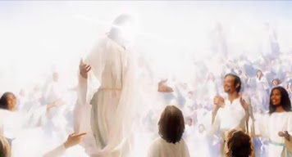

I want to share with you what the Lord allowed me to see regarding the rapture (harpazo: Greek - to seize upon, to snatch away or take to oneself. Found three times in the New Testament: Acts 8:39, 2 Corinthians 12:2-4, 1 Thessalonians 4:17, Revelation 12:5).
At first, I was allowed to experience the "catching away". I heard a loud sound; it was that of a trumpet, but more like a shofar. I was looking up at the sky. I remember seeing the clouds part as a glowing light broke through. I began to ascend quickly. I remember calling the name of the Lord over and over as it seemed I was picking up speed. I saw others, but I couldn't see them clearly. It was like I saw white silhouettes of people being pulled up with me (perhaps this had to do with the transformation that takes place mentioned by the Apostle Paul in 1 Corinthians 15:52).
I then found myself in a place, a great hall, full of people. There was a quiet hum of chatter; somehow peace radiated from it. It was the voices of the people greeting one another with joy. I looked through the endless crowd. I then noticed that to my right there was a more dense crowd, as if they were surrounding someone. My attention was drawn towards them. Somehow as my focus became directed at them, the crowd began to disperse. They made a pathway of sorts, almost like they read the curiosity of my mind to know who they were gathered around.
As the path cleared, there He stood: Yeshua. Dressed in a beautiful floor-length white robe, that seem to shimmer with lights, He had a gold crown upon His head, and a gold sash tied around his waist. He was absolutely stunning!
We made eye contact, but I chose not to approach Him (I've often said to the Lord that if I made it home; if I had done enough to please Him in this life that He saw it fit to allow me to return to Him, all I wanted was to just be able to make eye contact with Him, and the only thing I wanted in return was a smile. That's all I needed. It would be our way of communicating; our way of simply saying, 'I made it'). Yeshua looked at me with those piercing eyes, smiled and nodded in greeting.
I have not seen much of heaven. I was taken to the Throne Room of the Father back in August of 2014. That experience was granted to me after I complained like a spoiled toddler about never seeing heaven when Christ inquired about His desire to take me into hell. However, heaven has never been a place that I felt far from. In other words, I've been a person who has spent much of her life looking up: never being able to fit in this life; always being deemed strange, peculiar, eccentric, even an "old soul". I stood out from childhood. I didn't have many friends, but I talked to angels. I always knew that I came from a place that wasn't here. Even when I attempted to run from the breath of God that was continuously on the back of my neck, I simply couldn't. He owned me. And there was a point in my life when I despised that fact. He would allow me to stumble, fail, be misunderstood, humiliated, and often rejected because He was jealous over me. He never wanted me to conform to this world, nor would He ever allow me to obtain earthly power, fame, nor riches so that I would always be reminded that I didn't belong here. Thankfully, years later, I live by the simple rule of, 'what the King wants, the King gets', and there are no exceptions.
I was allowed to see a glimpse of the aftermath of the rapture (harpazo) here on earth.
I saw an unknown highway here in the United States. There were wrecked vehicles piled up everywhere and some were on fire. I given the understanding that the mass accidents was not so much because too many people had disappeared, but because a person in this car, or that truck, even a public bus driver had been taken, so it caused a chain reaction. The strange thing that was revealed to me while seeing this was that no one died. No one was allowed to die that day, as if placed as a testament to what had taken place.
I then saw scientists and governments come together to try to explain the phenomenon that had taken place. They came up with the conclusion that is was an alien invasion. Announcements were broadcasted across televisions, cell phones, and internet that we now knew the answer to the "long-awaited" question of whether or not we were alone. I was made aware that there was previously another type of pledge/pandemic that rolled out after covid. The pressure to get vaccinated and tracked had spread worldwide. The leaders used what had transpired as a bridge to introduce a new biometric system that would count and track the people. I heard leaders say that just as it was important during the pandemic that people worked together, even more so now. And that is was important to get the biometric ID so that they could keep track of everyone so that no one else could disappear. It became a worldwide mandate and no citizen was allowed to function in society without it.
In another scene, I was looking through a small window. Outside, I saw complete chaos. Everything was moving at rapid speed, as if someone had pressed the fast-forward button on a movie. I saw people in great distress, famine, disease, and much death. I saw meteor showers of fire falling upon the earth, massive earthquakes, and worldwide droughts. I saw military tanks and soldiers from many nations marching to war. Then finally I saw the sky part and The Lord of Hosts with ten thousand, thousand of His elite returning to earth. I saw His foot touch down on the Mount of Olives, and as the ball of His foot touched the earth, a light blasted from Him and split the ground in two. The window then closed.
The message that the Lord wants me to give to the church is that, He is coming. And too many of us are still not ready. Many will be left behind simply because they did not search His word for the truth that He will call His Bride from the earth. There are too many that are distracted with recycled earth-bound prophecies from those who are seeking their kingdom in THIS life, instead of that of the next. Too many are caught up in irrelevant things, debates, and arguments that they have deemed relevant, yet do not bring in the harvest. The Lord said the majority of those who are shouting "revival" hearts are dark, and most don't even hear His voice. The Lord said that a time of famine is upon the land: a famine for the Word of the Lord. This is a season of quiet. The storm is already upon us, and warnings have already gone forth. So don't find yourself caught up in searching for the prophetic in people; what you will mostly find is that which is false. Seek Him. Repent of the wickedness of your heart and turn to Him, and He will set you free. The Lord said many are still battling with bitterness(unforgiveness), fear, perversion, and pride. Seek Him while you can yet still find Him, for the door is closing.
As with all things, take this to prayer for confirmation.

Shalom
Mena Lee Grebin
Faithful Walk Healing Ministries

WHY HELL
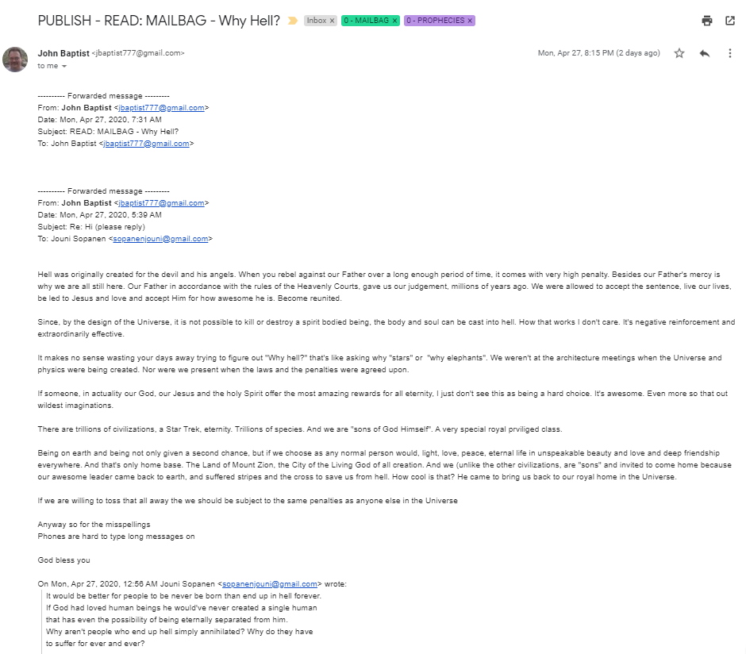

We will look into that. What?
Trump War Room - Text TRUMP to 88022 (@TrumpWarRoom) tweeted at 8:09 PM on Fri, Apr 17, 2020:
The Obama-Biden Administration reportedly gave $3.7 million to the Chinese lab in Wuhan that is the subject of the investigation into the origin of the coronavirus.
President Trump says he is looking at it and "we will end that grant very quickly."
https://twitter.com/trumpwarroom/status/1251301753896742914?lang=en

Mention America due to Her Sin being Destryed by the Virus A mysteriously masked Hugo Weaving enlists Natalie Portman's help to overthrow a totalitarian British government in the year 2020.

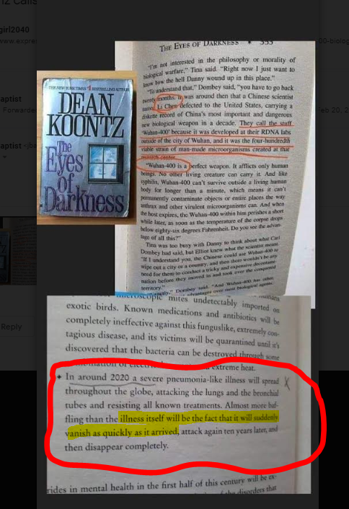

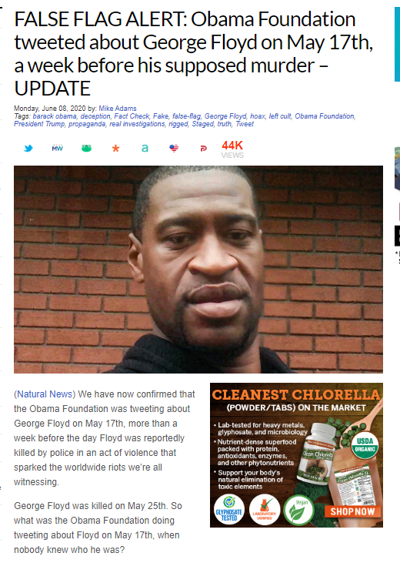

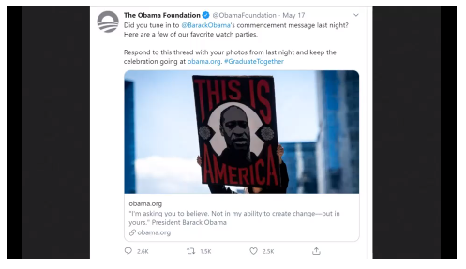

CIVIL WAR IN THE USA

ELECTION OF THE REMNANT

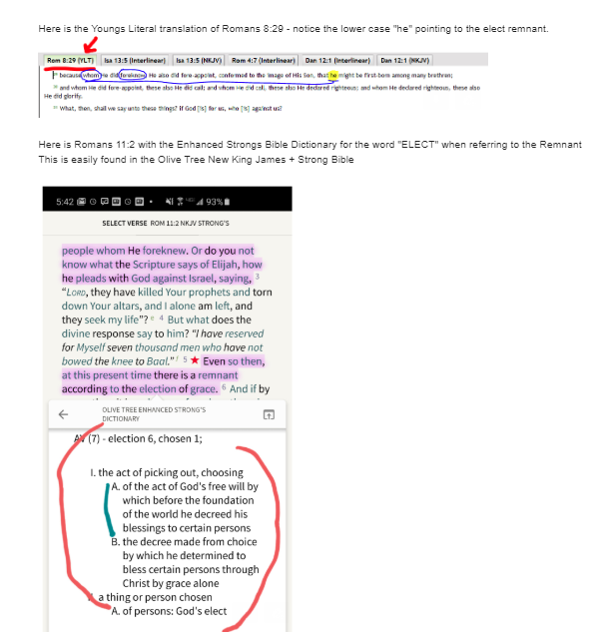
ROMANS 11:5

The ELECTION OF GRACE

CONFIRMATION OF WHAT THE LORD WAS SHOWING ME

HOT KEEPERS

Seals Events Timeline

WATCH LIST OF PROPHETIC JUDGMENT EVENTS

- Pacific North West Tsunamic Megaquake (Cascadia)
- Major California Earthquake (preceding Sixth Seal)
- Cosmic Object (asteroid) Hitting Sun Causing Solar Storm and Major Power Grid Outages
- Meteor Showers Causing Major Oil and Gas Fires
- Global Financial Collapse
- War North Korea, Sinking of US Aircraft Carrier
- Direct Missile Attacks and Foreign Troops on American Soil
- Israeli Jets Launch Tactical Nukes at Iran (Fordow)
- Major Man-Made Biological Attack, Pandemic Kills Millions
- Civil War and Unrest, Martial Law
- Libya Launches Nuclear Tipped Missile into Israel
- Gog / Magog Invasion Causes 2 Million in Israeli Losses
- Massive Increase in Volcanoes, Chaos, Mayhem, Riots
- Several Major US Cities Nuked (ground based)
- Russian, Chinese and North Korean Attacks on American Soil
- One or More Major Cataclysmic Events with Global Impact (Cosmic and Possible Earth Bound)
- Red Skies as a 24 Hour Warning Prior to the Meteor Hitting Atlantic
- METEOR STRIKE (opening Sixth Seal)
- Double Mega Tsunami Wiping Out East Coast of US and other countries

ALIEN INVASIONS & RAPTURE
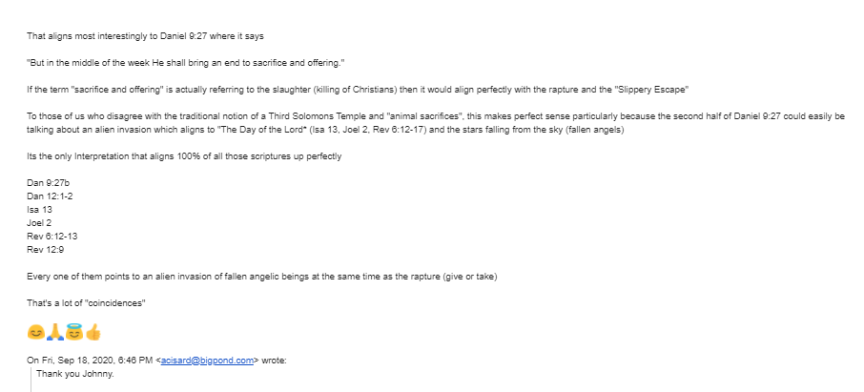

- Without Warning 1994
- Battle LA
- How the End Begins
- War of the Worlds (lightning)
- GREENLAND (2020)
NEWT GINGRICH – George Soros Evil

https://youtu.be/pGrvhC_cz1c

https://www.theblaze.com/glenn-radio/spiritual-battle?rebelltitem=1#rebelltitem1

NOBODY PAYS FOR ANY CRIME

https://youtu.be/YsjfHWj3BGE

(Note: This is saved locally)

OBAMA IS BACK TO DIVIDE AMERICA AS MUCH AS POSSIBLE

https://youtu.be/F6S_dcmyfq8

I WOULD DIE FOR TRUMP

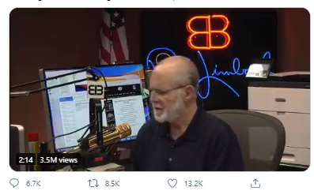

A caller who is near tears, distraught over election results, tells Rush Limbaugh that he's willing to die for Trump https://t.co/huVu0qfcgt
(https://twitter.com/existentialfish/status/1329847884997660677?s=03)

Obama and third term.mp3
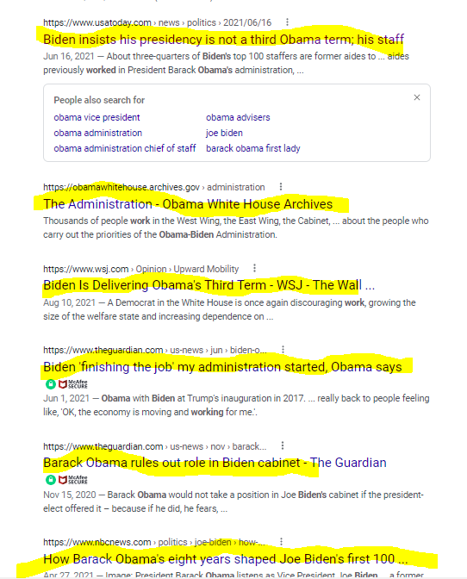

https://www.theblaze.com/shows/the-glenn-beck-program/glenn-beck-china-evergrande-collapse?rebelltitem=1#rebelltitem1

https://www.facebook.com/watch/?v=4872662019427741&ref=external
FDA HEARINGS ON VACCINE ISSUES

https://theexpose.uk/2021/09/18/fda-experts-reveal-the-covid-19-vaccines-are-killing-2-people-for-every-1-life-saved/

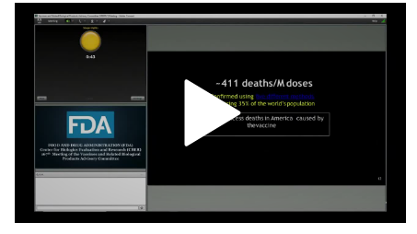
SALVE TO WARD OFF EFFECTS FROM SHEDDDING

WALMART CENTERS PREPARING FOR DISASTER

https://www.bitchute.com/video/TpCcoiJT42yt/

Tucker Carlson reveals a powerpoint from the U.S. Army justifying vaccine mandates with a slide that says "How many children were sacrificed to Satan for the vaccine?" along with listing the 7 tenets of Satanism
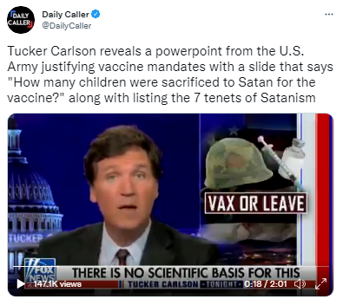

https://t.co/a6SmmNwLvS
(https://twitter.com/DailyCaller/status/1440107751477231621?s=03)

WARNING BIDEN POOPING HIMSELF

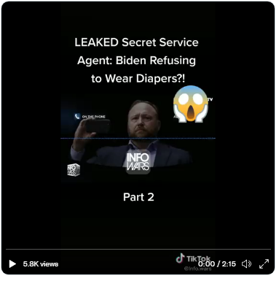

https://twitter.com/jillrteamxrp/status/1440122824912474115?s=11

https://twitter.com/JillRTeamXRP/status/1440099702528110592

https://www.glennbeck.com/radio/glenn-warns-prepare-for-no-access-to-scripture

https://twitter.com/SicarioScott/status/1443189243690508289

FUNNY

http://www.jokes4us.com/animaljokes/chickenjokes.html

https://www.backyardchickencoops.com.au/The-Top-10-Best-Chicken-Jokes

https://funkidsjokes.com/jokes-about-chickens/

https://humoropedia.com/funny-chicken-jokes/

https://www.backyardchickens.com/articles/you-crack-me-up-funny-chicken-jokes-and-stories.72151/

How do baseball players stay cool when they play?
They sit by their fans.

Did you hear about the monster with five legs?
His trousers fit him like a glove.

What do you call an elephant that doesn't matter? An irrelephant.

What do lawyers wear to court? Lawsuits!

Where do crayons go on vacation? Color-ado!

What did the femur say to the patella? I kneed you.
Did Adam and Eve ever have a date? A. No, it was an apple!

What does a cat have that no other animal has? Kittens.

Wanna hear a bad cat joke? Just kitten!

How do you weigh a millennial? In Instagrams.

Are any Halloween monsters good at math? No—unless you Count Dracula!

Why didn’t they play cards on the Ark?
Because Noah was always standing on the deck.

Which is the longest word in the dictionary?
"Smiles", because there is a mile between each "s"!

Which month do soldiers hate most?
The month of March!
What did the painter say to the wall?
One more crack like that and I'll plaster you!

Why did the M&M go to college?
Because he wanted to be a Smarty.

What stays on the ground but never gets dirty?
A shadow.

Did you hear about the crab that went to the seafood disco?
He pulled a muscle

What did one raindrop say to the other?
Two's company, three's a cloud.

What do you call a Bee who is having a bad hair day?
A frisbee.

What kind of shorts do clouds wear?
Thunderwear

What do snowmen eat?
Frosted Flakes.

1. What do you call an ant who fights crime?
A vigilante!
—Joe L., age 10
2. What is fast, loud and crunchy?
A rocket chip!
3. Why did the teddy bear say no to dessert?
Because she was stuffed.
4. What has ears but cannot hear?
A cornfield.
5. What did the left eye say to the right eye?
Between us, something smells!
6. Why did the police play baseball?
He wanted to get a catch!
—Yuna, age 8

7. What did the microwave say to the other microwave?
Is it just me? Or is it really hot in here?
—Yuna, age 8
8. Why did the student eat his homework?
Because the teacher told him it was a piece of cake!
9. When you look for something, why is it always in the last place you look?
Because when you find it, you stop looking.
10. What is brown, hairy and wears sunglasses?
A coconut on vacation.

11. Two pickles fell out of a jar onto the floor. What did one say to the other?
Dill with it.
12. What did the Dalmatian say after lunch?
That hit the spot!
13. Why did the kid cross the playground?
To get to the other slide.
14. How does a vampire start a letter?
Tomb it may concern...
15. What do you call a droid that takes the long way around?
R2 detour.
16. How do you stop an astronaut’s baby from crying?
You rocket!
17. Why was 6 afraid of 7?
Because 7, 8, 9
18. What is a witch’s favorite subject in school?
Spelling!
19. When does a joke become a “dad” joke?
When the punchline is a parent.
20. How do you make a lemon drop?
Just let it fall.
21. What did the limestone say to the geologist?
Don’t take me for granite!
22. What do you call a duck that gets all A’s?
A wise quacker.
23. Why does a seagull fly over the sea?
Because if it flew over the bay, it would be a baygull.
24. What kind of water cannot freeze?
Hot water.
25. What kind of tree fits in your hand?
A palm tree!

26. Why did the cookie go to the hospital?
Because he felt crummy.
27. Why was the baby strawberry crying?
Because her parents were in a jam.
28. What did the little corn say to the mama corn?
Where is pop corn?
29. What is worse than raining cats and dogs?
Hailing taxis!
30. How much does it cost a pirate to get his ears pierced?
About a buck an ear.
31. Where would you find an elephant?
The same place you lost her!
32. How do you talk to a giant?
Use big words!
33. What animal is always at a baseball game?
A bat.
34. What falls in winter but never gets hurt?
Snow!
35. What do you call a ghost’s true love?
His ghoul-friend.

36. What building in New York has the most stories?
The public library!
37. What did one volcano say to the other?
I lava you!
38. How do we know that the ocean is friendly?
It waves!
39. What is a tornado’s favorite game to play?
Twister!
40. How does the moon cut his hair?
Eclipse it.
41. How do you get a squirrel to like you?
Act like a nut!
42. What do you call two birds in love?
Tweethearts!
43. How does a scientist freshen her breath?
With experi-mints!
44. How are false teeth like stars?
They come out at night!

45. How can you tell a vampire has a cold?
She starts coffin.

46. What’s worse than finding a worm in your apple?
Finding half a worm.
47. What is a computer's favorite snack?
Computer chips!!
—reader Rebecca K.
48. Why don’t elephants chew gum?
They do, just not in public.
49. What was the first animal in space?
The cow that jumped over the moon
50. What did the banana say to the dog?
Nothing. Bananas can’t talk.
51. What time is it when the clock strikes 13?
Time to get a new clock.
52. How does a cucumber become a pickle?
It goes through a jarring experience.
53. What do you call a boomerang that won’t come back?
A stick.
54. What do you think of that new diner on the moon?
Food was good, but there really wasn’t much atmosphere.
55. Why did the dinosaur cross the road?
Because the chicken wasn’t born yet.
56. Why can’t Elsa have a balloon?
Because she will let it go.
57. How do you make an octopus laugh?
With ten-tickles!
58. How do you make a tissue dance?
You put a little boogie in it.
59. What's green and can fly?
Super Pickle!
60. Knock knock.
Who’s there?
Interrupting pirate.
Interrupting pir—yarrrrrr!
61. What did the nose say to the finger?
Quit picking on me!
62. What musical instrument is found in the bathroom?
A tuba toothpaste.
63. Why did the kid bring a ladder to school?
Because she wanted to go to high school.
64. Where do vampires keep their money?
A blood bank.
65. What do elves learn in school?
The elf-abet.
66. What do you call a dog magician?
A labracadabrador.
67. Where do pencils go on vacation?
Pencil-vania.
68. Why couldn't the pony sing a lullaby?
She was a little horse.
69. What do you cakes and baseball have in common?
They both need a batter!
70. What gets wetter the more it dries?
A towel.
71. What do you call two bananas?
Slippers.
And speaking of bananas...
72. Why did the banana go to the doctor?
Because it wasn’t peeling well.
73. What do you call a fake noodle?
An impasta.
74. What stays in the corner yet can travel all over the world?
A stamp.
75. How do you fix a cracked pumpkin?
With a pumpkin patch.
76. What kind of award did the dentist receive?
A little plaque.
77. What do you call a funny mountain?
Hill-arious.
78. Why are ghosts bad liars?
Because you can see right through them.
79. Why do bees have sticky hair?
Because they use a honeycomb.
80. What did the big flower say to the little flower?
Hi, bud!
81. There are two robots sitting on a wall. They are named Pete and Re-Pete. Pete falls off. Who is left?
(Re-Pete...so you repeat the whole thing again and again and again.)
82. What is a pony’s favorite juice?
She really likes lemon-neigh’d.
—5-year-old Kerrigan
83. Where do fish keep their money?
In the River-Bank!
84. What do you call an alligator with a vest?
An investigator!
85. Why was the computer cold?
It left its window open!
86. Knock knock!
Who’s there?
Boo.
Boo who?
Don’t cry!
87. In baseball, would it take longer to run from 1st to 2nd base or 2nd to 3rd base?
2nd to 3rd base because there’s a shortstop in between.
88. What has lots of leaves but never actually grew?
A book!
89. Why was the computer cold?
It had a virus.
90. Why did the invisible man turn down the job offer?
Because he couldn’t see himself doing it.

91. Who keeps the ocean clean?
The mer-maid.

92. What did the astronaut say when he crashed into the moon?
"I Apollo-gize."
93. Why didn’t the orange win the race?
It ran out of juice.
94. What dinosaur had the best vocabulary?
The thesaurus.
95. What did one DNA strand say to the other DNA strand?
Do these genes make my butt look big?
96. Why aren’t dogs good dancers?
They have two left feet.
97. What did the wolf say when it stubbed its toe?
Owwwww-ch! (by Henrik, age 5)
98. Kid: What are you doing under there?
Mom: Under where?
Kid: Ha ha! You said underwear!!
99. Why did Johnny throw the clock out of the window?
Because he wanted to see time fly.
100. What did one toilet say to the other?
You look flushed.
101. Why did the man put his money in the freezer?
He wanted cold hard cash!
102. Why couldn't the astronaut book a hotel on the moon?
Because it was full.
103. How do pickles enjoy a day out?
They relish it.
104. What do you call an old snowman?
Water.
105. What's a pirate's favorite letter?
Arrrrrrrrrr
106. What do you get when you cross an elephant with a fish?
Swimming trunks.
107. How do you throw a party in space?
You planet.
108. What did zero say to eight?
Nice belt!
109. What happened when the skunk was on trial?
The judge declared, "Odor in the court, odor in the court!"

APOCALYPTIC

NEWS

HOLINESS QUOTES
More GREAT QUOTES
"God has one destined end for mankind - holiness! His one aim
is the production of saints. God is not an eternal blessing-
machine for men. He did not come to save men out of pity. He
came to save men because He had created them to be holy."
-Oswald Chambers
"If you think you can walk in holiness without keeping up perpetual
fellowship with Christ, you have made a great mistake. If you
would be holy, you must live close to Jesus."
-Charles Spurgeon
"Holiness has never been the driving force of the majority. It is,
however, mandatory for anyone who wants to enter the kingdom."
-Elisabeth Elliot
"Many Christians have what we might call a 'cultural holiness.'
They adapt to the character and behavior pattern of Christians
around them... But God has not called us to be like those around
us. He has called us to be like Himself. Holiness is nothing less
than conformity to the character of God."
-Jerry Bridges
"Do not expect to grow in holiness if you spend little time alone
with God and do not take His Word seriously."
-Joel Beeke

SMITH WIGGLESWORTH QUOTES

GREAT QUOTES from WIGGLESWORTH
"Before God could bring me to this place He has broken me a
thousand times."
- Smith Wigglesworth.
"The Lord would so cleanse the motive and desires of our hearts
that we will seek but one thing only, and that is, His glory."
- Smith Wigglesworth.
"There are four principles we need to maintain : First, read the
Word of God. Second, consume the Word of God until it consumes
you. Third believe the Word of God. Fourth, act on the Word of God."
- Smith Wigglesworth.
"God has privileged us in Christ Jesus to live above the ordinary
human plane of life. Those who want to be ordinary and live on a
lower plane can do so, but as for me, I will not."
- Smith Wigglesworth
" The devil knows if he can capture your thought life he has won
a mighty victory over you."
- Smith Wigglesworth
"You must come to see how wonderful you are in God and how
helpless you are in yourself."
- Smith Wigglesworth.
"Real faith built the ark, but real faith did not shut the door. God
did that. He does what you cannot do."
- Smith Wigglesworth.
"When things are not going right, there are satanic forces in
operation... I can pray in the Holy Ghost, and that prayer is
effectual to bring down every stronghold of the enemy."
- Smith Wigglesworth.
"Life comes after you have been filled with the Holy Ghost, get
down and pray for power."
- Smith Wigglesworth.
"There is something about believing God that will cause Him to
pass over a million people to get to you."
- Smith Wigglesworth.
"The secret of spiritual success is a hunger that persists... It is
an awful condition to be satisfied with one´s spiritual attainments...
God was and is looking for hungry, thirsty people."
- Smith Wigglesworth

SCRIPTURE OF THE DAY MINI MIRACLE lol

1 Corinthians 2:14

But the natural man does not receive the things of the Spirit of God, for they are foolishness to him; nor can he know them, because they are spiritually discerned.

HOW TO LIVE THESE DAYS?

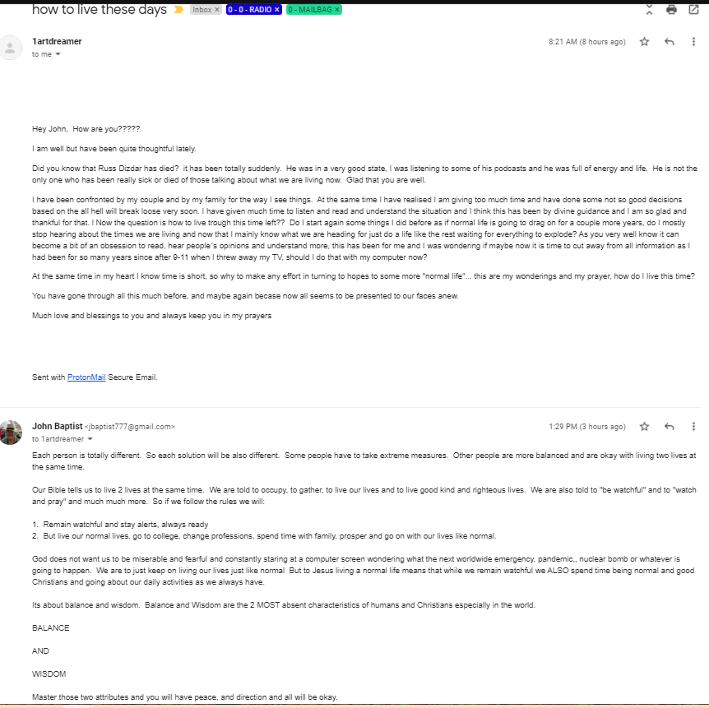

NEW HEADLINES
1. Trucking shortages
2. Shipping Jams
3. Empty Shelves
4. Energy Costs up 40%
5. Supply Chain Interrruptions (for all goods)
6. Services, Restaurants, Movies, Hotesl down
7. 5-20% Inflation
8. Airlines unable to fly to many cities due to anti-vaxers
9. 911 Emergency Call systems are unmanned
10. Major healthcare worker shortages by the tens of thousands
11. Film Crews (60,000) on strike this monday
12 AND THE WORST ONE OF ALLLLLLLL
PUMPKIN SHORTAGES!!!!!!!!!!!!!!!!!
Now .....

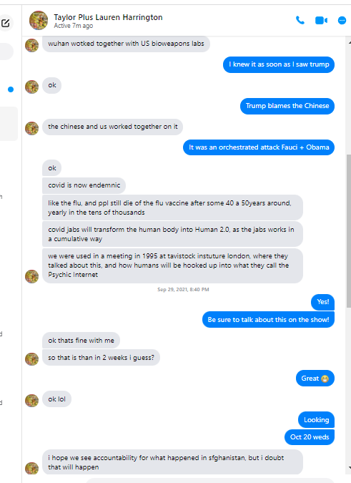

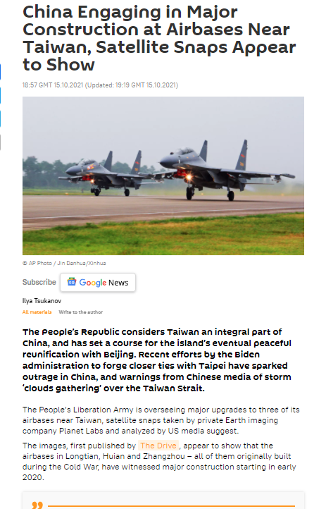

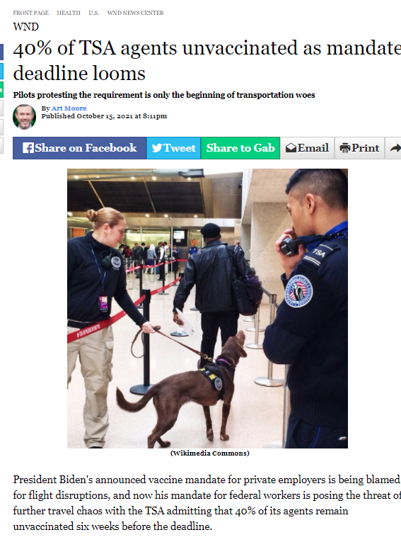
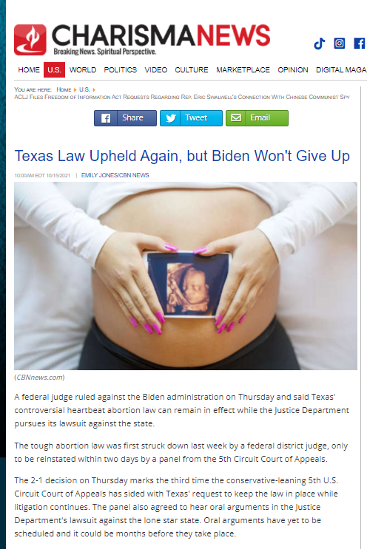

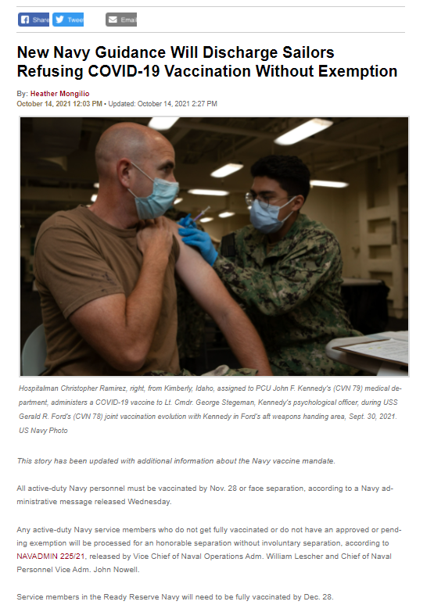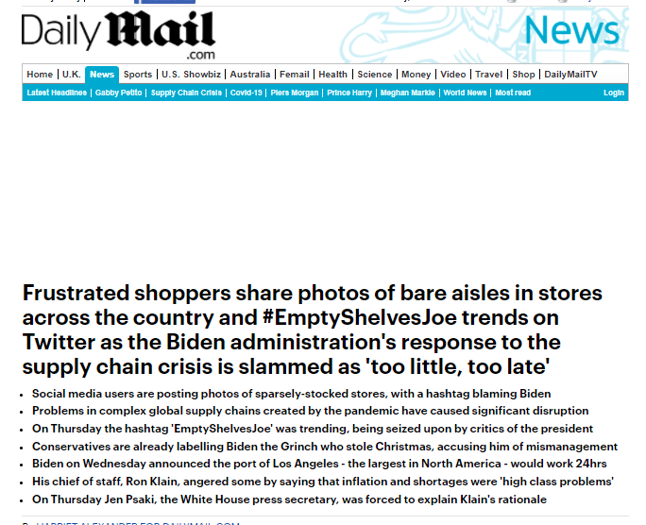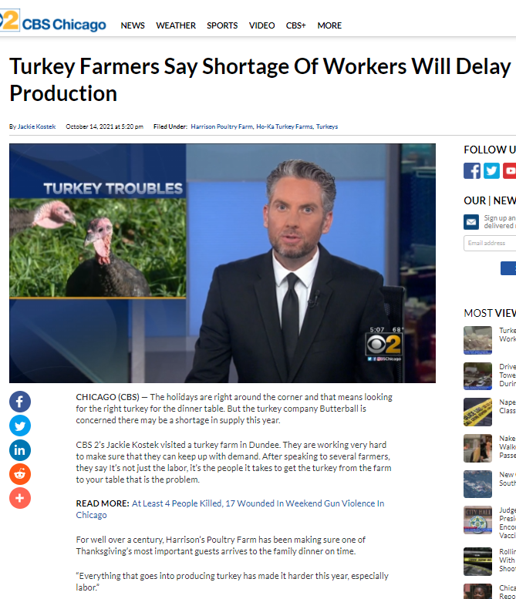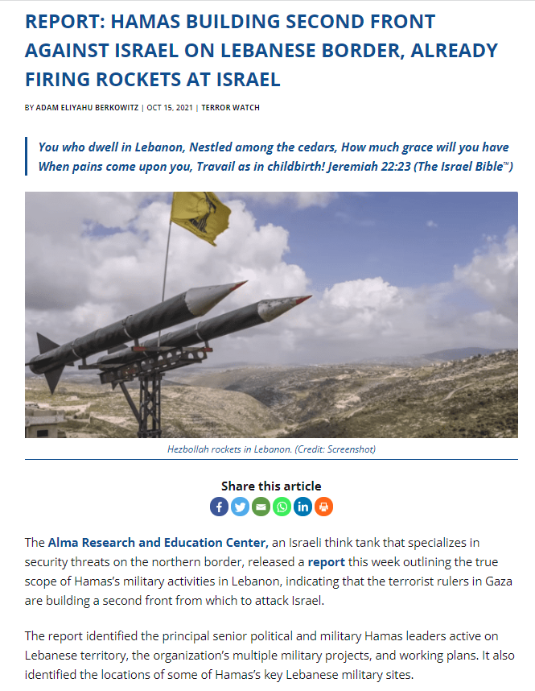

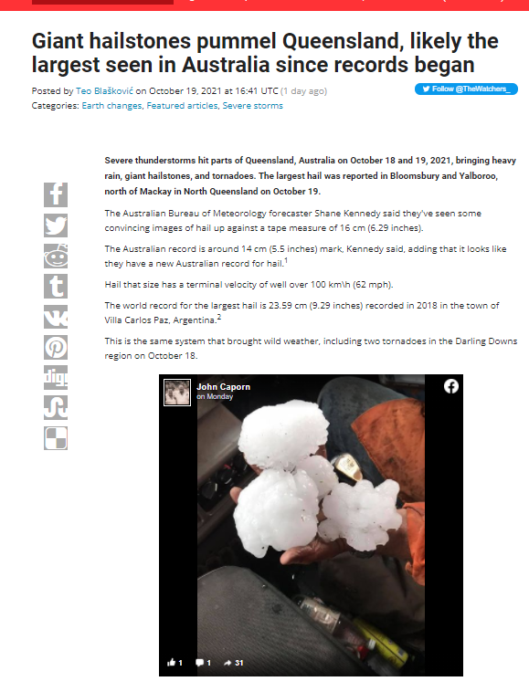
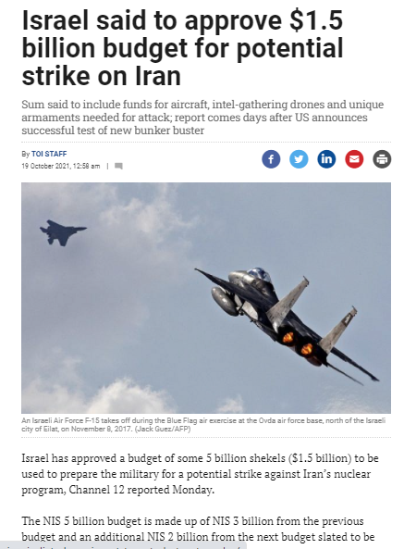

START HERE

Designated Survivor Commercial
Because of an Attack on Our Capital

https://youtu.be/-XDedMlK2a8

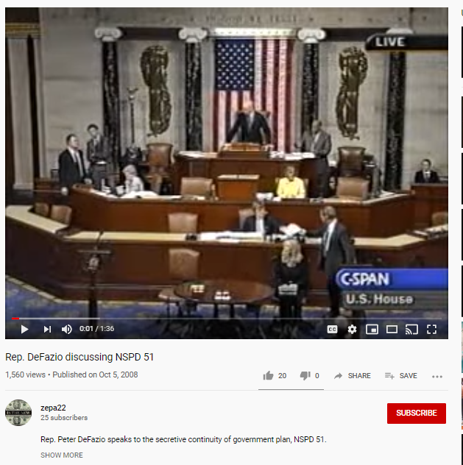 PLAY – Congressman Peter Defazio Contests PDD 51 Continuity of Government

Mailbag\ SUDDENLY

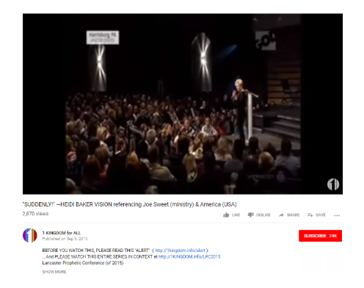

https://youtu.be/NpBAXx1W3Ak

PLAY – Suddenly – The Heidi Baker Vision

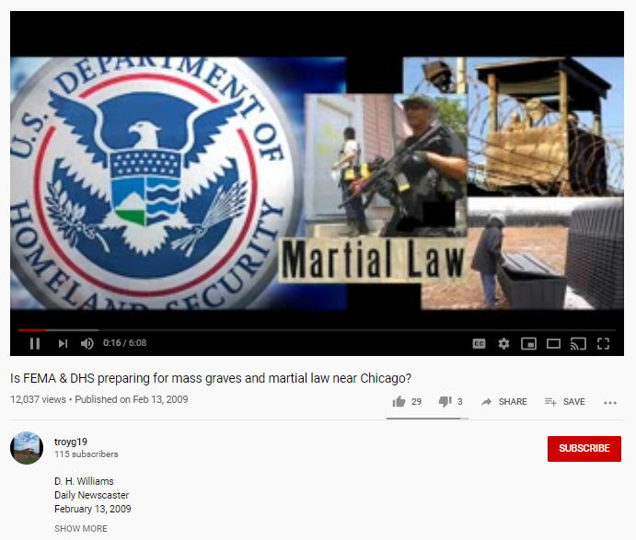

PLAY
CHICAGO – FEMA DHS MASS GRAVES NEAR CHICAGO
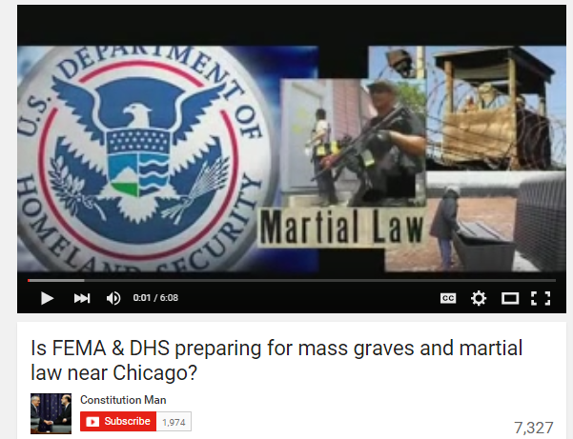

https://www.youtube.com/watch?v=O3Ks_WFSQqk

American Riots will be the Worst in the World (06:38)
Chicago – Is FEMA DHS Mass Graves Near Chicago

NWO – John Bolton CPAC – The Benefits of Nuking Chicago

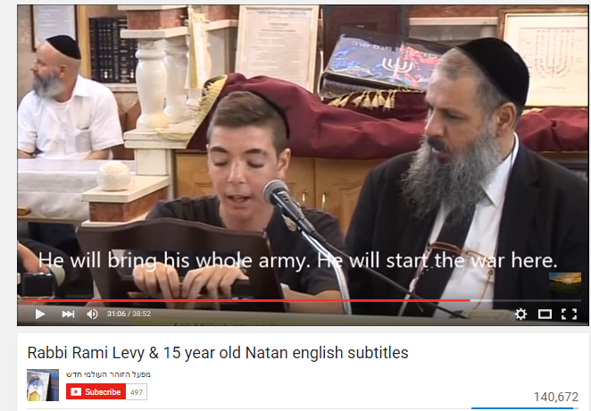

https://www.youtube.com/watch?v=AJynlrKfsCE
Rabbi Rami Levy & 15 year old Natan

Transcript - Rabbi Rami Levy & 15 year old Natan on Gog Magog (Johnny Baptist)

Planet X – Rogue Planet (4) – Gradual Climate Change, Long Winters …
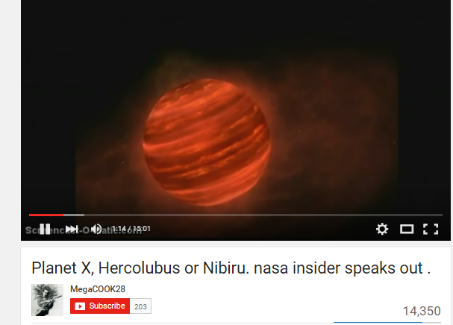

https://www.youtube.com/watch?v=6sE-gxB2amE

Planet X – Nibiru NASA Insider (short) BOOM

PERSECUTION

Persecution

TORTURED FAMILY, CHILDREN CRY OUT DON’T GIVE IN DAD

http://therightscoop.com/isis-tortures-11-year-old-in-front-of-his-christian-missionary-father-crucifies-them-for-not-converting-to-islam
From Christian Aid Mission:
At several steps on their path to death by beheading and crucifixion last month, 11 indigenous Christian workers near Aleppo, Syria had the option to leave the area and live. The 12-year-old son of a ministry team leader also could have spared his life by denying Christ.
The indigenous missionaries were not required to stay at their ministry base in a village near Aleppo, Syria; rather, the ministry director who trained them had entreated them to leave. As the Islamic State (ISIS), other rebel groups and Syrian government forces turned Aleppo into a war zone of carnage and destruction, ISIS took over several outlying villages. The Syrian ministry workers in those villages chose to stay in order to provide aid in the name of Christ to survivors.
“I asked them to leave, but I gave them the freedom to choose,” said the ministry director, his voice tremulous as he recalled their horrific deaths. “As their leader, I should have insisted that they leave.”
They stayed because they believed they were called to share Christ with those caught in the crossfire, he said.
And then they became captives of ISIS. Relatives relate what happened.
The relatives said ISIS militants on Aug. 7 captured the Christian workers in a village whose name is withheld for security reasons. On Aug. 28, the militants asked if they had renounced Islam for Christianity. When the Christians said that they had, the rebels asked if they wanted to return to Islam. The Christians said they would never renounce Christ.
The 41-year-old team leader, his young son and two ministry members in their 20s were questioned at one village site where ISIS militants had summoned a crowd. The team leader presided over nine house churches he had helped to establish. His son was two months away from his 13th birthday.
In front of the team leader and relatives in the crowd, the Islamic extremists cut off the fingertips of the boy and severely beat him, telling his father they would stop the torture only if he, the father, returned to Islam. When the team leader refused, relatives said, the ISIS militants also tortured and beat him and the two other ministry workers. The three men and the boy then met their deaths in crucifixion.
“All were badly brutalized and then crucified,” the ministry leader said. “They were left on their crosses for two days. No one was allowed to remove them.”
The martyrs died beside signs the ISIS militants had put up identifying them as “infidels.”
Somehow people want us to believe that these evil monsters would have been boy scouts if George W. Bush hadn’t invaded Iraq. And of course, it has absolutely nothing to do with Islam, right?
Unfortunately, other horrors were recounted as well. These perpetrated on Christian women.
Eight other ministry team members, including two women, were taken to another site in the village that day (Aug. 28) and were asked the same questions before a crowd. The women, ages 29 and 33, tried to tell the ISIS militants they were only sharing the peace and love of Christ and asked what they had done wrong to deserve the abuse. The Islamic extremists then publicly raped the women, who continued to pray during the ordeal, leading the ISIS militants to beat them all the more furiously.
As the two women and the six men knelt before they were beheaded, they were all praying.
“Villagers said some were praying in the name of Jesus, others said some were praying the Lord’s prayer, and others said some of them lifted their heads to commend their spirits to Jesus,” the ministry director said. “One of the women looked up and seemed to be almost smiling as she said, ‘Jesus!'”
After they were beheaded, their bodies were hung on crosses, the ministry director said, his voice breaking. He had trained all of the workers for their evangelistic ministry, and he had baptized the team leader and some of the others.
This is what is happening in the Middle East right now.
And instead of doing anything about it, Obama is sitting back and letting Turkey’s Erdogan attack his enemies among the Kurds in Syria, and letting Putin attack the enemies of his pal Assad. We’re not even leading from behind anymore, we’re just ceding ground to Satanic evil every day.
Read more: http://therightscoop.com/isis-tortures-11-year-old-in-front-of-his-christian-missionary-father-crucifies-them-for-not-converting-to-islam/#ixzz40ChMrUmU

Strange Sounds – Czech Republic
Strange Sounds – Budapest Hungary
Strange Sounds – Von Helton
UFO-Alien – War of the Worlds – Horn Blast Tripod Sound
Strange Sounds – Jamie Maussan – Strange Sounds Linked to Motherships

Sound Effect – Helicopter

FINANCIAL COLLAPSE

Financial Collapse

THROW SILVER AND GOLD INTO THE STREETS

Ezek 7:19
'They will throw their silver into the streets,
And their gold will be like refuse;
Their silver and their gold will not be able to deliver them
In the day of the wrath of the Lord;
They will not satisfy their souls,
Nor fill their stomachs,
Because it became their stumbling block of iniquity.
NKJV

GUEST SEGMENT

NICK REDFERN

However, This book title of his looks good.......FINAL EVENTS and the Secret Government Group on Demonic UFOs and the Afterlife https://www.amazon.com/dp/1933665483/ref=cm_sw_r_other_apa_i_4ffyEb1XCVQ7S
- Planet X
- Elenin
- FEMA Camps
- FEMA Coffins
- FEMA Trains
- Mass Graves
- Nake Body Scanners
- Guillotines
- Mind Control Slaves
- Georgia Guide Stones
- Islamic Rise, Mahdi Messiah
- Operation Garden Plot
- MK Ultra
- 911
- NorthCOM
- Government Relocation to Denver
- Atlantis, Lemuria
- Middle East Muslim Riots
- Deep Underground Military Bases
- Public Video Surveillance Cameras
- Unified Global Control Grid
- World Government / NATO
- Presidential Directives
- Military Industrial Complex
- Chemtrails
- HAARP
- Magneto Leviton Train Systems
- GMO Foods
- Seed Vaults
- Terminator Seeds
- Codex Alimentarious
- Chip Implants
- Ancient Aliens
- Hidden Nukes, Micro Nukes
- Underwater Pyramids
- ForeignTroop Buildups
- Martial Law
- UFO’s around the Sun
- Hybridized humans
- Akhenaten Hieroglyphs
- Pyramid Shaped UFOs
- Super Soldiers
- Financial Collapse, IMF Super-currency
- Disclosure Secrecy
- Zecharia Sitchin
- Corruption of the Human Genome
- Hybridized Humans
- Shape Shifting Reptilians
- Perfectly Possessed Humans
- Vibrational Shifts
- Mainstream Media UFO Reports
- CERN Accelerator
- Wikileaks
- God Particle
- Anti-Matter Accumulators
- Star Gates, Wormholes, Spirals
- Asteroids, Comets, Cosmic Disturbances
- UFO Wars in Earth’s Atomosphere
- 3rd Generation Night Vision Goggles
- Earth Wobbles
- UFO FBI Documents
- Ecumenical Religious Initiatives
- Pole Shifts
- 5013C Government Church Controls
- Pleiadian Cosmic Visitations
- Global Seismic Indicators
- Rise of the New Ager Beliefs
- Indigo Children / Star Children
- Kundalini Spiritual Events
- Personal Angels
- Energy Orbs
- Light Workers
- Economic Turmoil
- Media Front Loading
- Alien Movies, UFO Movies, ET Lyrics
- Endless Distractions
- Earthquakes, Volcanos, Tornados, and Extended Winters
- Animal Die-Offs
- Pandemics, Manufactured Poisons, Pineal Gland Destruction

HEAVEN NOTES:

Not everyone sees the same parts of Heaven

Never throw the Baby out with the Bathwater

READ: My Dream of Heaven – Rebecca Springer

- Tasks

Flight to HEAVEN
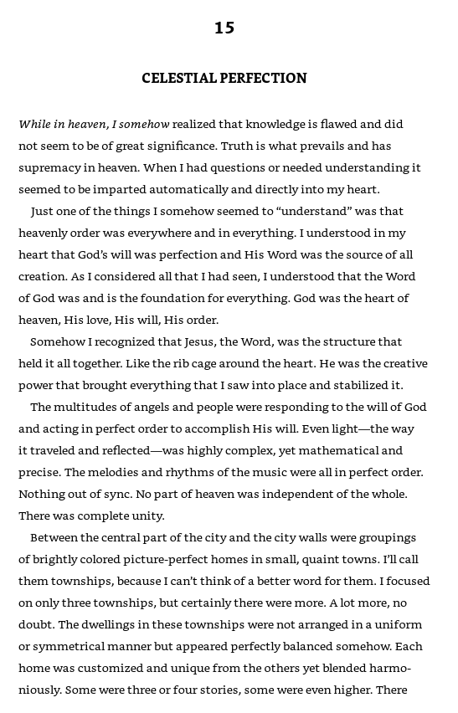
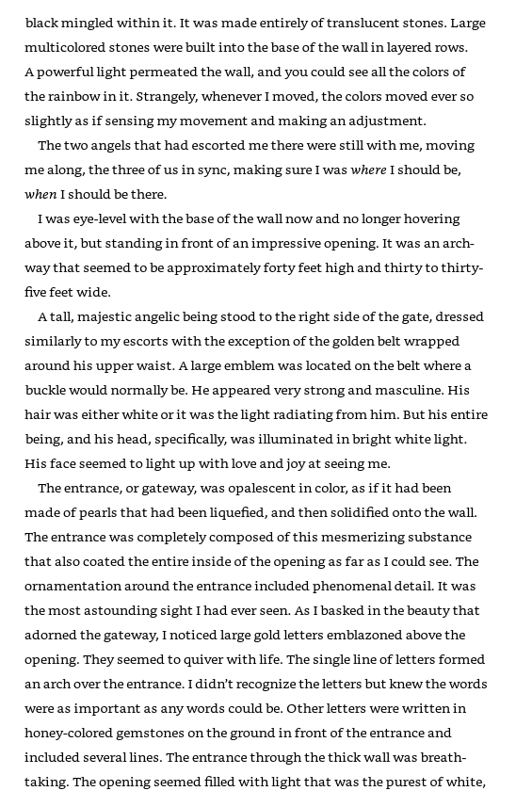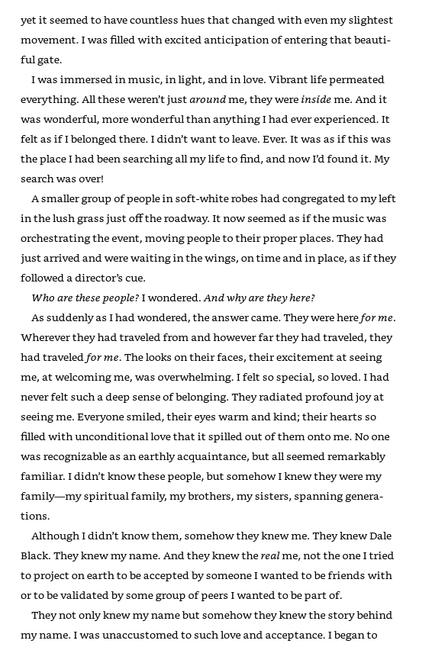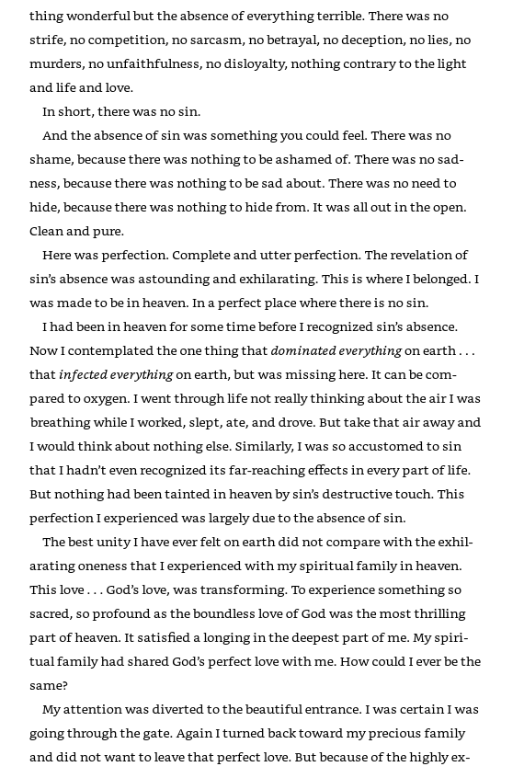

MY DREAM OF HEAVEN – Rebecca Springer
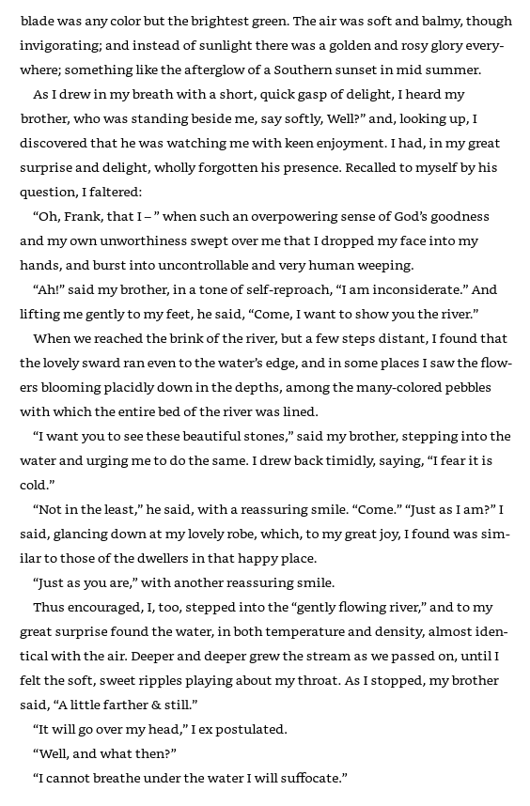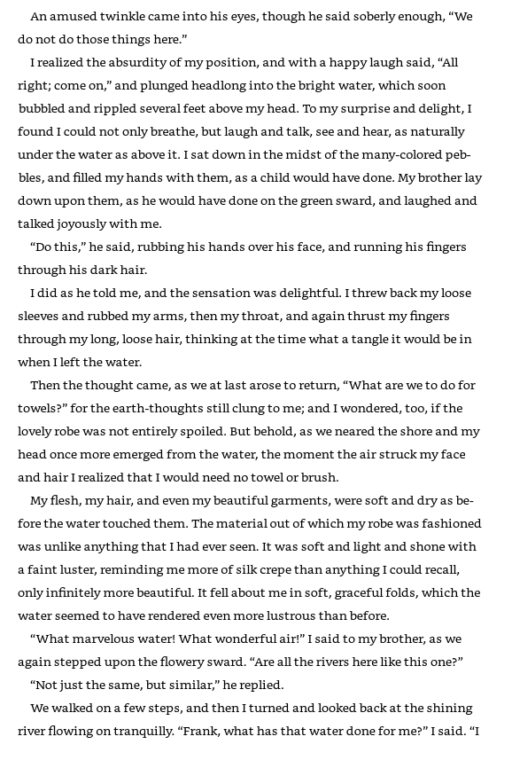
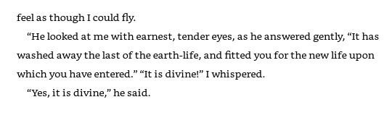

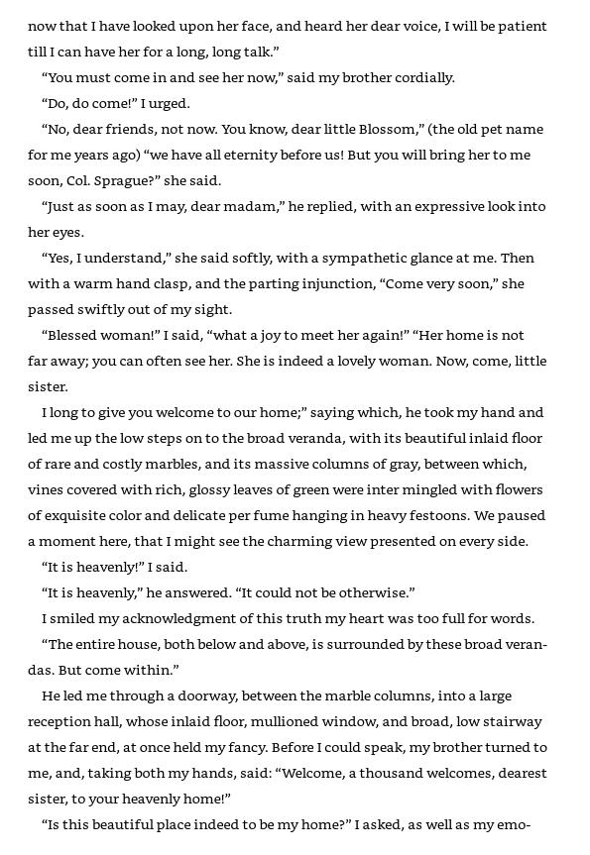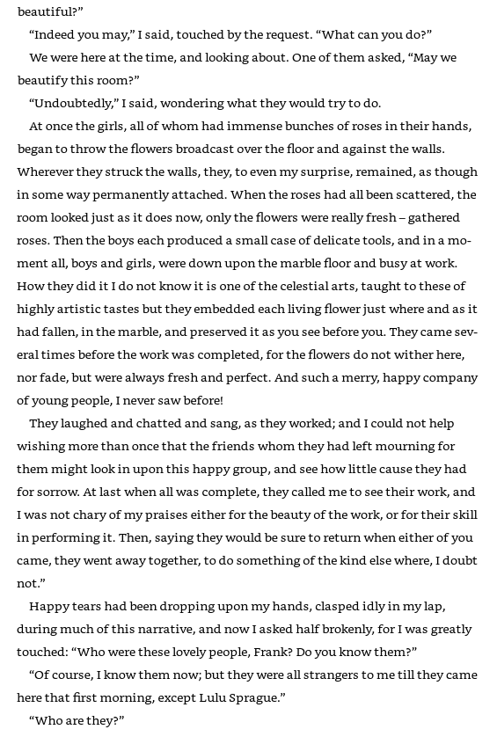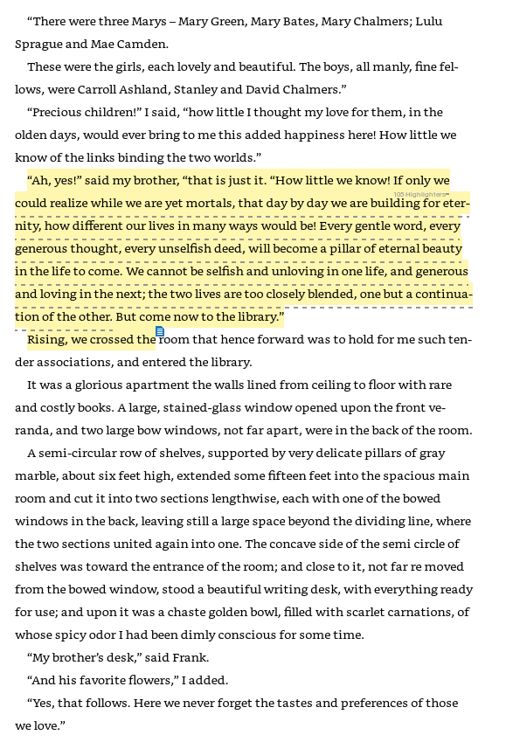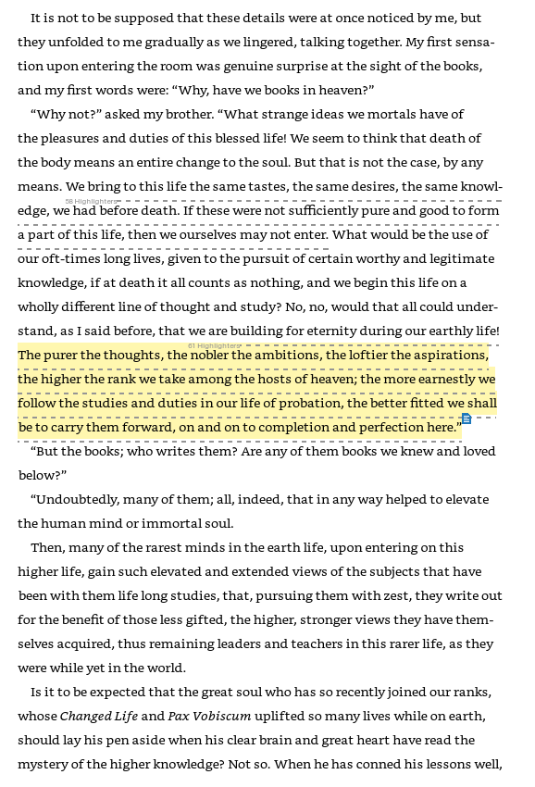
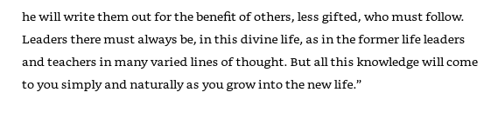

The Outer Darkness

Mount Zion, City of God
Heb 12:22-24
22 But you have come to Mount Zion and to the city of the living God, the heavenly Jerusalem, to an innumerable company of angels, 23 to the general assembly (congress) and church of the firstborn who are registered in heaven, to God the Judge of all, to the spirits of just men made perfect, 24 to Jesus the Mediator (Lawyer/Advocate) of the new covenant, and to the blood of sprinkling that speaks better things than that of Abel.
NKJV

Kingdom of God vs. Kingdom of Heaven

About mansions, although I really want a thomas kinkade cottage in the woods. And a beautiful white owl.

What we'll be doing.

Will I be able to sit on my father's lap as he caresses my head, cause I never had that.

Will our family members greet us 1st? I have a grandbaby there.

Will my family, praying that they'll make it, be together with me all eternity ie. My husband, kids, grandkids?

Will we have jobs or do what God has chosen us to really be?

Besides the cottage, I also want all color Rose's and other flowers to give to people. I've always wanted my own floral shop.

Also anything about the marriage supper of the lamb.

About 1 Corinthians 2:9. Also any interactions with universal, other planets, or beings.

Oden Hetrick – City Mansion, Country Mansions

PLAY ODEN HETRICK CLIPS

END OF SHOW

